**Year 1 Spring 1 Health and Well Being**

**What helps us to stay healthy?**

**Previous Learning from the EYFS Curriculum**

**Area of Learning: Personal Social and Emotional Development**

**Aspect: Managing Self**

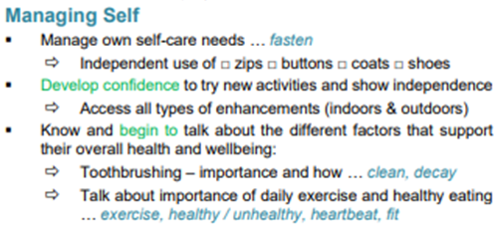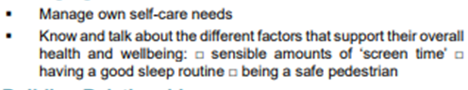

**Vocabulary**

* Being healthy
* Hygiene
* Medicines
* people who help us with health

**Key Knowledge for unit**

**Children will learn:**

* what being healthy means and who helps help them to stay
* healthy (e.g. parent, dentist, doctor)
* that things people put into or onto their bodies can affect how
* they feel
* how medicines (including vaccinations and immunisations) can help people stay healthy and that some people need to take medicines every day to stay healthy
* why hygiene is important and how simple hygiene routines can stop germs from being passed on
* what they can do to take care of themselves on a daily basis, e.g. brushing teeth and hair, hand washing