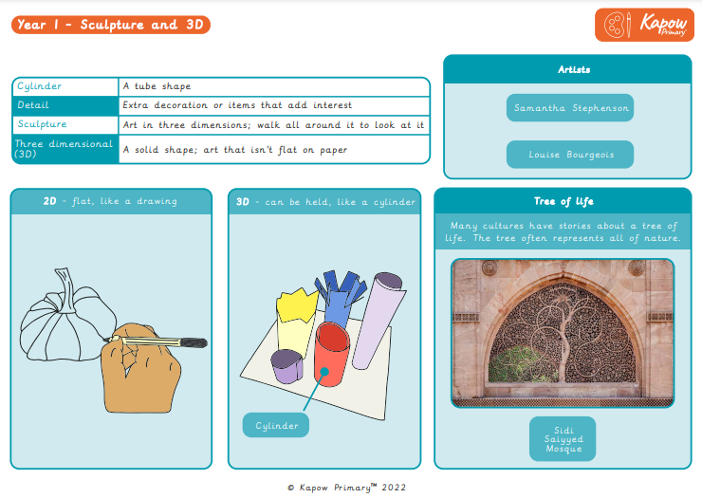

Key Skills & Vocabulary:

**Summer 1**

**3D Sculpture**