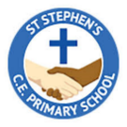

**Year 2 Topic Web**

Autumn 1

**English –**

Our ‘book for hook’ for this half term is ‘Man on the Moon (a day in the life of Bob)’. The children will focus on using punctuation correctly and recording their ideas using cursive handwriting. Children will create their own narratives and instructions relating to our class text.

**Maths-**

We will be focussing on number, place value, addition and subtraction this half term. The children will practise reading and writing numbers to 100, compare and order numbers, and count in 2’s, 5’s and tens. Children will also practise strategies for adding and subtracting numbers within 100.

Everyday Materials

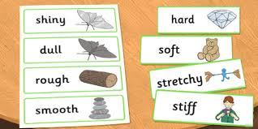

**Science**-

We will be learning about everyday materials and their properties. Children will learn how materials can change and compare the suitability of materials by creating accessories for ‘Bob’.

**Computing-**

Our computing topic for this half term is ‘Isafe’. Children will re-visit online safety rules and learn how to use technology safely and independently.

**Art/DT**

In Art we will be exploring using charcoal and other drawing materials to create a story by drawing though observation of toys made from different materials. We aim for our stories to meet Bob on a new space adventure.

**History-** We will be learning about significant explorers including Neil Armstrong, Christopher Colombus and Ibn Battuta. We will create timelines, research the significant events of their lives and how they contributed to our understanding of the word (and beyond!) today.

**RE-** We find out what parables are, and that Christians believe these stories were told by Jesus to teach his followers about God. We learn about the parable of the Lost Son and what this story teaches many Christians about God, including God being loving and forgiving. Pupils think carefully about what it means for Christians to ask for forgiveness from God and the promise that people will be welcomed back into God’s family

**PE:**

Children will develop their teamwork and cooperation skills within team games and have weekly sports development lessons with Active Tameside.