# 

**Year 2 Curriculum Overview**

Summer 1 2025

**SCIENCE 🦴🦴**This half term children will be learning about biodiversity. Children will learn about the difference between an insect and a minibeast. They will familiarise themselves with ecosystems and different types of animals that live in them.

**MUSIC 🪕**

Year 2 will be learning a new song called the ‘Friendship Song.’ Children will explore the elements of music and compare these with different songs.

**ENGLISH**Our new book in English is ‘Cake Girl’. We will be exploring the story and immersing ourselves with the text. Children will build up to writing a set of instructions and writing a non-chronological report.

We will also be continuing our Phonics learning using our Read Write Inc scheme to help us become more fluent readers.

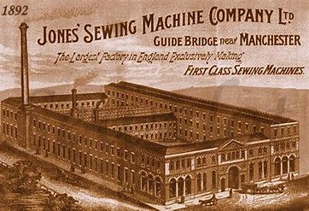

**History**

In history we will learn about the history of the factory outside of our window. Children will research what it was used for and the living conditions of child workers back in Victorian times.

**PSHCE – Relationships.**

In PSHCE children will be learning about families and how some families might be different. Children will also learn how to keep safe and knowing there are lots of different physical contact and know what is acceptable and what is not.

**COMPUTING** Making Music

Year 2 children will be listening to a variety of pieces of music and consider how music can make them think and feel. They will compare creating music digitally and non-digitally.

**ART**

Year 2 will be manipulating clay and using a range of tools to create different shapes. Children will learn the correct terminology and will build a house out of clay.

**MATHS**In Maths we will begin to learn fractions. Children will consolidate their learning on part and whole, and build on this to recognise different fractions such as: ½, ¾, ¼.

Children will then move onto telling the time. This includes telling the time by the hour, half, quarter and by the minute.

**R.E. –** “How should we care for others and the world?

Children will be learning about why we should care about others and our world.

**P.E. 🏀**We will be practising their, hitting, catching and running skills through a variety of sports.

**MUSIC**

We will be learning about rhythm and music notation.