# 

**Year 2 Curriculum Overview**

Spring 2 2025

**SCIENCE 🦴🦴**This half term children will be studying plants. We will be looking how seeds and bulbs grow into maturing plants. We will also find out what a plant needs to grow and stay healthy and the reproduction cycle of a plant.

**MUSIC 🪕**

Year 2 will be learning songs which include elements of reggae music with a focus on the dimensions of different songs.

**ENGLISH**In English this half term we will be focusing on our new book ‘Grandpa’s Island’. Within this text we will be focusing on writing a set of instructions and create a diary recount as well as engaging with poetry later in the half term.

We will also be continuing our Phonics learning using our Read Write Inc scheme to help us become more fluent readers.

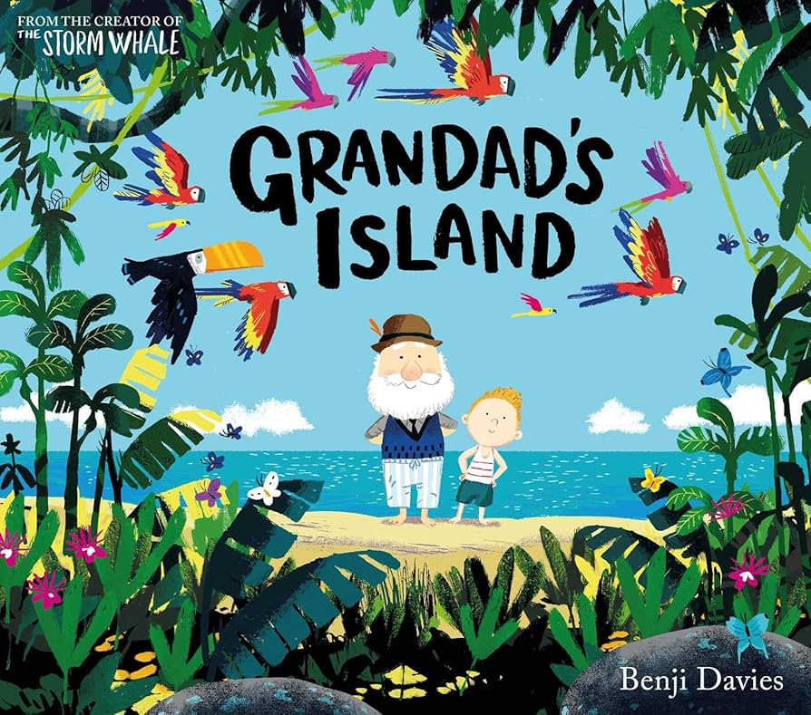

**Geography**

We will be completing a fieldwork study learning about where our food comes from. This study will look at food sources from our local area, the regions of the UK and the different countries around the world.

**PSHCE – Healthy me!**

We will be learning on the different ways which we can keep ourselves healthy both physically and mentally. Children will explore how we can keep calm and what we can do to relax, and how we can keep our bodies healthy.

**COMPUTING** Data and Information

We will be learning how to use pictograms. They will create these to organise and present data usually using pictogram software.

**DT**

This half term in DT we will be creating a fairground wheel. Over this time, children will be learning how axles help move a vehicle and how this applies to the mechanism of a fairground wheel. Children will be able to choose what materials will best suit their designs and give reasonings why they have designed it this way.

**MATHS**In Maths we will continue to consolidate our learning of Multiplication and division as we work our way up to practising our times tables. We will then begin to learn about length and height exploring different measurements such as centimetres and millimetres.

We will then progress onto learning about mass, capacity and temperature where children will learn about weight and measuring the capacity of containers in millilitres and litters.

**R.E. –** “Why does Easter matter to Christians?”

Children will be learning about the meaning of Easter and its importance to the Christian Faith.

**P.E. 🏀**We will be practising their, hitting, catching and running skills through a variety of sports.

**MUSIC**

We will be learning about rhythm and music notation.