# 

**Year 2 Curriculum Overview**

Spring 1 2025

**SCIENCE 🦴🦴**This half term we will be completing our unit on ‘Living Things and their Habitats’. We will be exploring and comparing the differences between things that are living, dead, and things that have never been alive. We will also identify that most living things live in habitats to which they are suited and describe how different habitats provide for the basic needs of different kinds of animals and plants, and how they depend on each other

**MUSIC 🪕**

Year 2 will be learning songs which include elements of rock and how to use more of the dimensions of Music.

**ENGLISH**In English we will be reading a variety of stories to help us create our own narratives based on unfamiliar settings. We will be using the learning from these stories to also then create non-chronological reports and recounts as well as engaging with poetry.

We will also be continuing our Phonics learning using our Read Write Inc scheme to help us become more fluent readers.

**Change and New Beginnings**

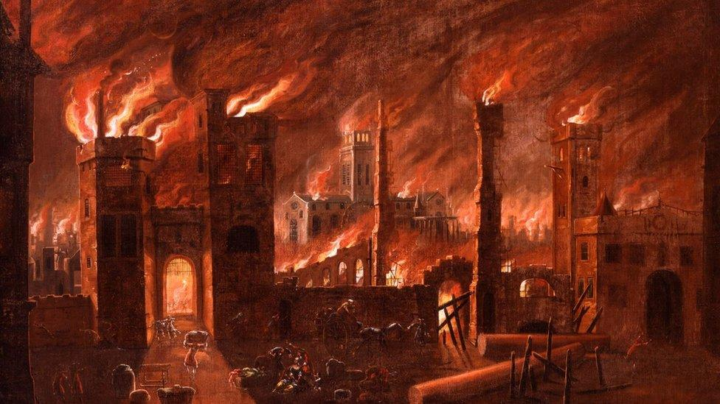

**Art – ‘Drawing and Painting’**

We will be learning about creating textures, observational drawing, character expression, and storytelling through illustrations, enhancing pupils' mark-making techniques, observational skills, and imagination in art.

**PSHCE – Dreams and Goals**

We will be learning about how to set a realistic goal, how to persevere when a task is difficult, how to work well in a team as well as how to share successes with other people.

**History**

We will be learning about the Great Fire of London and how this cause changed our capital city completely.

**MATHS**In Maths we will be consolidating our learning of Addition & Subtraction before then continuing onto learning about Money and then begin learning about Multiplication and Division .

We will be learning to add and subtract two digit numbers with further exchanging, the value of notes and coins and we will be learning about equal groups and how repeated addition can be substituted with multiplication.

**COMPUTING** Programming

We will be learning to use given commands in different orders to investigate how the order affects the outcome. We will also learn about design in programming. We will then design algorithms and then test those algorithms as programs and debug them.

**R.E. - “Who is Jewish and how do they live?”** We will be learning about the Jewish faith and how they differ to Christian beliefs.

**P.E. 🏀**We will be learning team building games and working on Tag Ruby with a specialist coach. **PE on Mon and Thurs!**

**MUSIC**

We will be learning about rhythm and music notation.