National Curriculum Purpose of Study:  A high-quality geography education should inspire in pupils a curiosity and fascination about the world and its people that will remain with them for the rest of their lives. Teaching should equip pupils with knowledge about diverse places, people, resources and natural and human environments, together with a deep understanding of the Earth’s key physical and human processes. As pupils progress, their growing knowledge about the world should help them to deepen their understanding of the interaction between physical and human processes, and of the formation and use of landscapes and environments. Geographical knowledge, understanding and skills provide the frameworks and approaches that explain how the Earth’s features at different scales are shaped, interconnected and change over time | National Curriculum Aims:  The national curriculum for geography aims to ensure that all pupils:  - develop contextual knowledge of the location of globally significant places – both terrestrial and marine – including their defining physical and human characteristics and how these provide a geographical context for understanding the actions of processes  - understand the processes that give rise to key physical and human geographical features of the world, how these are interdependent and how they bring about spatial variation and change over time  - are competent in the geographical skills needed to: collect, analyse and communicate with a range of data gathered through experiences of fieldwork that deepen their understanding of geographical processes  - interpret a range of sources of geographical information, including maps, diagrams, globes, aerial photographs and Geographical Information Systems (GIS) communicate geographical information in a variety of ways, including through maps, numerical and quantitative skills and writing at length
National Curriculum Attainment targets:  By the end of each key stage, pupils are expected to know, apply and understand the matters, skills and processes specified in the relevant programme of study. | National Curriculum Subject content KS1 and KS2:  - Locational knowledge  - Place knowledge  - Human and Physical Geography  - Geographical skills and fieldwork

 | KS1 |  | KS2
 | Year 1 | Year 2 | Year3 | Year 4 | Year 5 | Year 6
Locational Knowledge  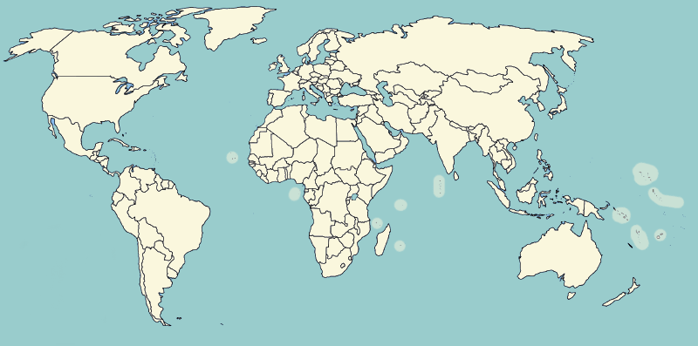 | Name, locate and identify characteristics of the four countries and capital cities of the United Kingdom and its surrounding seas. | Name and locate the world’s seven continents and five oceans. | Locate and name the continents on a World Map.  Locate the main countries of Europe inc. Russia.  Identify capital cities of Europe.  Locate and name the countries making up the British Isles, with their capital cities.  Identify longest rivers in the world, largest deserts, and highest mountains.  Compare with UK.  Identify the position and significance of Equator, N. and S. Hemisphere, Tropics of Cancer and Capricorn. | On a world map, locate areas of similar environmental regions, either desert, rainforest or temperate regions.  Locate and name the main counties and cities in/around …. | Locate the main countries in Europe and North or South America. Locate and name principal cities.  Compare 2 different regions in UK rural/urban.  Locate and name the main towns and cities in England.  Linking with History, compare land use maps of UK from past with the present, focusing on land use.  Identify the position and significance of latitude/longitude and the Greenwich Meridian. Linking with science, time zones, night and day | On a world map locate the main countries in Africa, Asia and Australasia/Oceania. Identify their main environmental regions, key physical and human characteristics, and major cities.  Linking with local History, map how land use has changed in local area over time.  Name and locate the key topographical features including coast, features of erosion, hills, mountains and rivers. Understand how these features have changed over time.
Place Knowledge  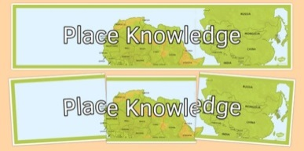 | Understand geographical similarities and differences through studying the human and physical geography of a small area of the United Kingdom, and of a small area in a contrasting non-European country. | Understand geographical similarities and differences through studying the human and physical geography of a small area of the United Kingdom, and of a small area in a contrasting non-European country concentrating on islands and sea sides. | Compare a region of the UK with a region in Europe, e.g. Local hilly area with a flat one or under sea level. Link with Science, rocks. | Understand geographical similarities and differences through the study of human and physical geography of a region of the United Kingdom, a region in a European country, and a region within North or South America. | Compare a region in UK with a region in N. or S. America with significant differences and similarities. E.g. Link to Fairtrade of bananas in St Lucia (see Geography.org etc for free and commercially available packs on St Lucia focussing on Geography). | Compare a region in UK with a region in N. or S. America with significant differences and similarities. E.g. Link to Fairtrade of bananas in St Lucia (see Geography.org etc for free and commercially available packs on St Lucia focussing on Geography). Understand some of the reasons for similarities and differences.
Human & Physical Geography  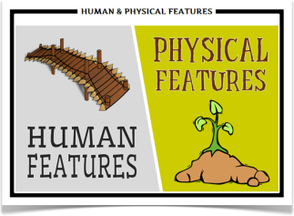 | Identify seasonal and daily weather patterns in the United Kingdom.  Identify the location of hot and cold areas of the world in relation to the Equator and the North and South Poles  Use basic geographical vocabulary to refer to:  ▪ Key physical features, including: forest, hill, mountain, soil, valley, vegetation,.  ▪ Key human features, including: city, town, village, factory, farm, house, office. | Use basic geographical vocabulary to refer to:  ▪ key physical features, including: beach, cliff, coast, forest, hill, mountain, sea, ocean, river, soil, valley, vegetation, season and weather  ▪ key human features, including: city, town, village, factory, farm, house, office, port, harbour and shop | Describe and understand key aspects of:  Physical geography including Rivers and the water cycle, excluding transpiration, brief introduction to Volcanoes and earthquakes linking to Science: rock types.  Human geography including trade links in the Pre-roman and Roman era.  Types of settlements in Early Britain linked to History. Why did early people choose to settle there? | Describe and understand key aspects of:  Physical geography, including: climate zones, biomes and vegetation belts.  Types of settlements in modern Britain: villages, towns, cities. | Describe and understand key aspects of :  Physical geography including coasts, rivers and the water cycle including transpiration; climate zones, biomes and vegetation belts.  Human geography including trade between UK and Europe and ROW  Fair/unfair distribution of resources (Fairtrade).  Types of settlements in Viking, Saxon Britain linked to History. | Describe and understand key aspects of :  Physical geography including Volcanoes and earthquakes, looking at plate tectonics and the ring of fire.  Distribution of natural resources focussing on energy
Geographical Skills & Field work  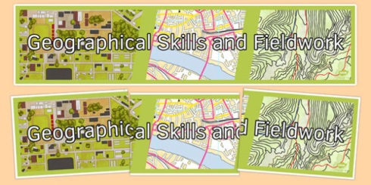 | Use world maps, atlases and globes to identify the United Kingdom and its countries.  Use simple fieldwork and observational skills to study the geography of their school and its grounds and the key human and physical features of its surrounding environment. | Use aerial photographs and plan perspectives to recognise landmarks and basic human and physical features; devise a simple map; and use and construct basic symbols in a key.  Use simple compass directions (North, South, East and West) and locational and directional language [for example, near and far; left and right], to describe the location of features and routes on a map. | Use maps, atlases, globes and digital/computer mapping (Google Earth) to locate countries and describe features studied.  Learn the eight points of a compass, 2 figure grid reference (maths co-ordinates), some basic symbols and key (including the use of a simplified Ordnance Survey maps) to build their knowledge of the United Kingdom and the wider world  Use fieldwork to observe and record the human and physical features in the local area using a range of methods, including sketch maps, plans and graphs, and digital technologies. | Use maps, atlases, globes and digital/computer mapping (Google Earth) to locate countries and describe features studied  Learn the eight points of a compass, four-figure grid references.  Use fieldwork to observe, measure and record the human and physical features in the local area using a range of methods, including sketch maps, plans and graphs, and digital technologies. | Use maps, atlases, globes and digital/computer mapping (Google Earth) to locate countries and describe features studied  Use the eight points of a compass, four-figure grid references, symbols and key (including the use of Ordnance Survey maps) to build their knowledge of the United Kingdom in the past and present.  Use fieldwork to observe, measure and record the human and physical features in the local area using a range of methods, including sketch maps, plans and graphs, and digital technologies. | Use maps, atlases, globes and digital/computer mapping (Google Earth) to locate countries and describe features studied  Extend to 6 figure grid references with teaching of latitude and longitude in depth.  Expand map skills to include non-UK countries.  Use fieldwork to observe, measure and record the human and physical features in the local area using a range of methods, including sketch maps, plans and graphs, and digital technologies.

