
DATE: 6th September, 2024

St Stephen’s CE Primary School
WEEKLY INFORMATION NEWSLETTER

Dear All,

Welcome back! I hope you had a great summer break and it was wonderful to see and hear the school full of children and staff again this week. It’s been a very busy summer with extensive work around all areas and rooms which will hopefully help us and the children going forward. It was a proud moment to hand out over 50 ‘School leadership’ roles and badges to the children this week after their applications last summer and this is a great reward and acknowledgement for those children.

Through various funding streams and grants we have updated the wi-fi connection (now running at 100x the speed), installed a new fire detection and alarm system, a new lock-down and panic button system, CCTV, door fobbing to restrict access to parts of the school, new benches (and soon an ‘urban garden) on the front yard, re -cladding of the new classrooms and re-painted them, new computers and ICT equipment, new classroom layouts to increase floorspace in some rooms and a new library…(it is due to arrive in a matter of weeks).

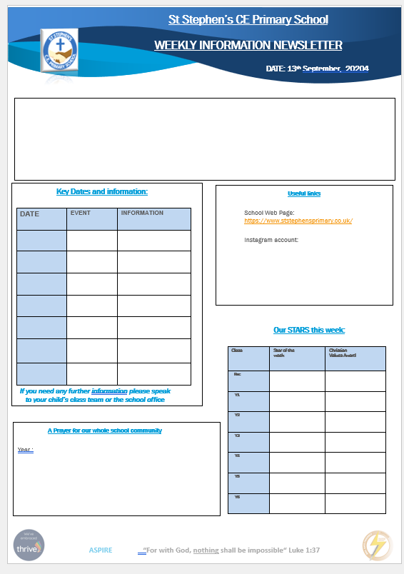
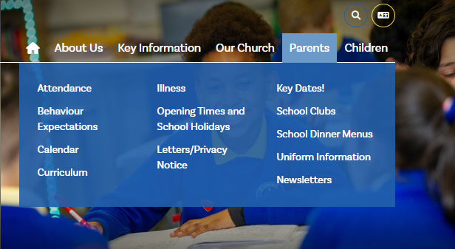
As we said last summer- this year we will produce a short newsletter like this each week and then a larger newsletter at the end of each half term, in an attempt to make information even more accessible. It will be emailed out on Friday each week and if you ask at the school office for a paper copy, they will be able to provide it to you in person. It will also be attached to the newsletter page on the new webpage.

Over this term we will be re-vamping the new webpage so that is it more informative to you…it just became live to us this week so please bear with us whilst we do this.

The Instagram page will post regular news from across the school and to sign up if you’ve not already done so is easy…. please scan the QR code on the left to do this and set an up an account if you are a new user, or request to follow us if you are already a user. It’s become a really popular addition to our school since we set this up last year …please like our posts as this helps us to see the information you enjoy receiving on INSTAGRAM ….or not!
Next week we will be operating a full timetable and also sending out information regarding after school clubs and activities to sign up to, and reminders about breakfast club and school meals. PE kit days were sent out by text as well as swimming lesson reminders (Y6 will swim this term and Y5 for the spring term). Y3 and 4 will have Ukelele lessons and specialist computing lessons this year from outside providers who will support our staff to pick up new skills and ideas for teaching too, which we’re all really excited about.
Finally, the diary for the term will be available on the website and on the Friday newsletter. We hope that this has helped more over the last year and please let your class teachers know any questions you have as a first port of call so we can get the correct information to you as quickly as possible.
Our school aim is to ASPIRE and our vision is “for with God, nothing shall be impossible”…we ask this of the children, our parents and community and of ourselves….and we have certainly started as we mean to go on since the summer term ended.

Mr Lovgreen
Headteacher

