Relationships and Behaviour Policy



|  |
| --- |
| Last reviewed on: June 2024 |
| Next review due by: June 2026 |

At St Stephen’s CE Primary School, our Christian values run through our school like a golden thread and enable our children to flourish and ASPIRE in life. Our Christian vision:

*for with God, nothing is impossible* Luke 1 : 37, helps support and guide our whole

school community in striving to beat our previous best endeavours.

Throughout the year, we re-focus on a Christian Value in order to keep God in the centre of our lives. By linking these to key events within the Christian calendar our children will all take turns in leading key collective worships for our whole school community at St Stephen’s Church, once a year.

|  |  |  |  |  |  |
| --- | --- | --- | --- | --- | --- |
| Autumn 1 | Autumn 2 | Spring 1 | Spring 2 | Summer 1 | Summer 2 |
| Thankfulness | Respect | Hope | Forgiveness | Love | Trust |

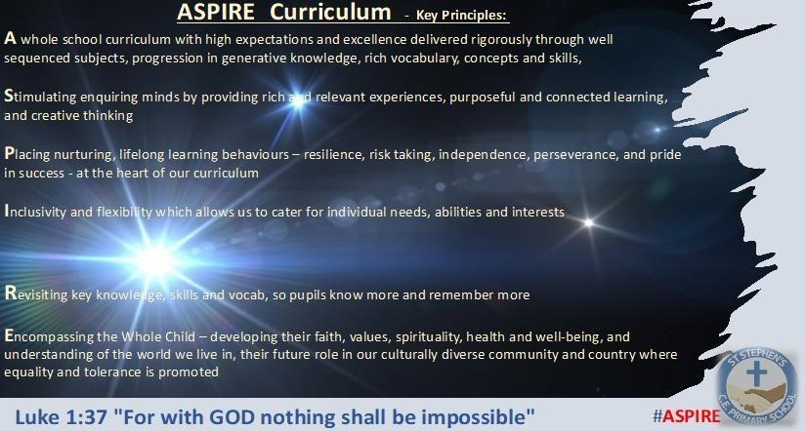

The key principles of our ASPIRE vision support our decision-making process at St Stephen’s CE Primary School for the curriculum. With these principles in place, our children are able to know more and remember more across development of our broad and balanced curriculum.

**School Aims – How we will ‘ASPIRE’ and show that ‘with God, nothing shall be impossible’** • Every child feels valued, safe and cared for, and makes a positive contribution to their own development and the life of the school, with Christ at its centre.

* Our bespoke and Inclusive, ASPIRE curriculum, based on excellence and high expectations, provides rich experiences which motivates, challenges, develops resilience and meets the needs of all children
* Every child achieves their potential and develops their talents and creativity, preparing them for a role in a global society with a lifelong love for learning
* Children & families develop understanding of a faith and Christian values that can guide their lives; knowing Jesus, and putting into action what they are coming to believe and value
* The whole school family flourishes and serves the local Church and community

The overriding aim of our school and our school’s curriculum is to ‘ASPIRE – for with God, nothing shall be impossible’ (Luke 1:34)

Our approach to Behaviour management supports this and all of our school Christian values; **Trust, Love, Thankfulness, Respect, Forgiveness & Hope**

# Rationale

At St Stephen’s Church of England Primary School, we believe that children learn best when they have Inclusive classrooms, clear rewards and consequences for their day-to-day conduct in and around school and kind and understanding relationships with children and adults like. If children feel safe and can enjoy their lessons, then they will learn and achieve. We have our values as a golden threads which run throughout our school. Through this policy and all our workings in school, we also promote the Christian and British concept of Restoration and the British Values of :

* democracy.
* the rule of law.
* individual liberty.
* mutual respect.
* tolerance of those of different faiths and belief

We do this through having 3 accessible and very understandable **School rules:**

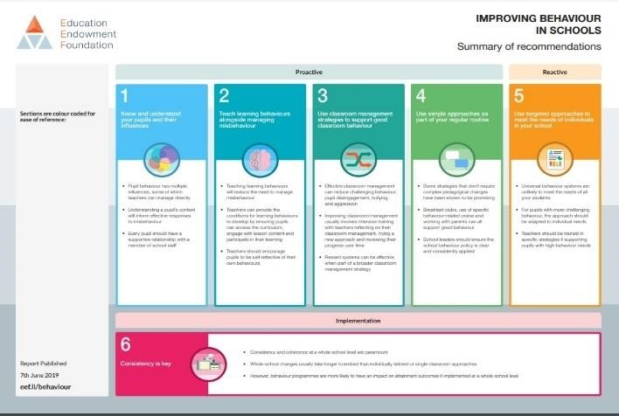We created these in consultation with staff, children and through research (EEF research

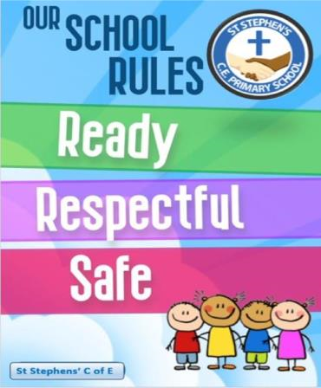

[https://educationendowmentfoundation.org.uk/educationhttps://educationendowmentfoundation.org.uk/education-evidence/guidance-reports/behaviourevidence/guidance-reports/behaviour a](https://educationendowmentfoundation.org.uk/education-evidence/guidance-reports/behaviour)nd Paul Dix ‘When the Adult changes’ )

**‘When the adults change’- key points**

“…Consistency is key. This means that all adults need to be on message all of the time.”

## About This Book

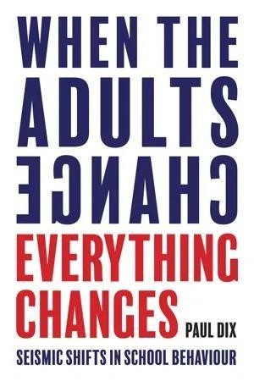*You can buy in the best behaviour tracking software, introduce 24/7 detentions or scream 'NO EXCUSES' as often as you want but ultimately the solution lies with the behaviour of the adults. It is the only behaviour over which we have absolute control.*

*Drawing on anecdotal case studies, scripted interventions and approaches which have been tried and tested in a range of contexts, from the most challenging urban comprehensives to the most privileged international schools, behaviour training expert and Pivotal Education director Paul Dix advocates an inclusive approach that is practical, transformative and rippling with respect for staff and learners. An approach in which behavioural expectations and boundaries are exemplified by people, not by a thousand rules that nobody can recall.*

*When the Adults Change, Everything Changes illustrates how, with their traditional sanction- and exclusion-led methods, the 'punishment brigade' are losing the argument. It outlines how each school can build authentic practice on a stable platform, resulting in shifts in daily rules and routines, in how we deal with the angriest learners, in restorative practice and in how we appreciate positive behaviour.*

*Each chapter is themed and concludes with three helpful checklists Testing, Watch out for and Nuggets designed*

*to help you form your own behaviour blueprint. Throughout the book both class teachers and school leaders will find indispensable advice about how to involve all staff in developing a whole school ethos built on kindness, empathy and understanding.*

*Suitable for all head teachers, school leaders, teachers, NQTs and classroom assistants in any phase or context, including SEND and alternative provision settings who are looking to upgrade their own classroom management or school behaviour plan.*

*When the Adults Change Everything Changes was a silver winner 2017 Foreword INDIES Awards in the Education category.*

To ensure St Stephen’s CE provides a happy, safe and respectful environment for all children to learn in; our school community has come together to agree a simple ‘Ready to Learn Code of Conduct’ that will support us in making good choices. This is displayed on all class noticeboards as a core expectation across the school. As with all learning, we believe that relationships and behaviour need to be modelled and taught to all children, frequently and revisited regularly.

Our PSHCE lead and Behaviour lead will implement the overviews for this and class teachers will take ever opportunity to promote, model and teach elements of positive relationships and behaviour to their class too.

St Stephen’s CE Primary school we expect that children can :

1. Always do their best and take pride in their work
2. Be respectful of others and school property
3. Follow instructions and always be honest
4. Walk around school and behave in a safe way
5. Keep their hands and feet to themselves and handle their feelings positively
6. Use friendly language and call people by their chosen name
7. Only bring to school what they need
8. Be in the right place at the right time
9. Have excellent manners and always be kind
10. Listen when others are speaking

We have rewards in place at school which include:

* Meaningful Praise
* Stickers
* House points linked to our collective Christian Values
* Conversations or phone calls home to parents
* Special responsibilities/privileges
* Weekly Teacher’s Star of the week, subject and Values Award
* Student Leadership positions

•

# BULLYING

Bullying is rare at St Stephen’s CE, and is defined as the repetitive, intentional harming of one person or group by another person or group, where the relationship involves an imbalance of power.

Bullying is, therefore:

* Deliberately hurtful
* Repeated, often over a period of time
* Difficult to defend against

Bullying can include:

|  |  |
| --- | --- |
| **Type of bullying** | **Definition** |
| Emotional | Being unfriendly, excluding, tormenting |
| Physical | Hitting, kicking, pushing, taking another’s belongings, any use of violence |
| Racial | Racial taunts, graffiti, gestures |
| Sexual | Explicit sexual remarks display of sexual material, sexual gestures, unwanted physical attention, comments about sexual reputation or performance, or inappropriate touching |
| Direct or indirect verbal | Name-calling, sarcasm, spreading rumours, teasing |
| Cyber-bullying | Bullying that takes place online, such as through social networking sites, messaging apps or gaming sites |

Details of our school’s approach to preventing and addressing bullying are set out in our antibullying strategy.

Sanctions may be applied where a pupil has misbehaved off-site when representing the school, such as on a school trip or on the way to or from school.

Where a pupil makes an accusation against a member of staff and that accusation is shown to have been malicious, the school will discipline the pupil in accordance with this policy.

Please refer to our statement of procedures for dealing with allegations of abuse against staff for more information on responding to allegations of abuse.

The headteacher will also consider the pastoral needs of staff accused of misconduct .

In some circumstances, staff may use reasonable and proportional force to restrain a pupil to prevent them:

* Causing disorder
* Hurting themselves or others
* Damaging property

Incidents of physical restraint must:

* Always be used as a last resort
* Be applied using the minimum amount of force and for the minimum amount of time possible
* Be used in a way that maintains the safety and dignity of all concerned
* Never be used as a form of punishment
* Be recorded and reported to parents by the persons involved immediately
* Logged on CPOMS and staff to de-brief by DSL/ DDSL
* Be administered by a Team Teach trained member of staff where possible.

# Roles and Responsibilities

Expectations of All Staff

* To take collective responsibility for the behaviour of all children within the school community and always following and positively contributing to the policy and ethos of the school.
* To provide a good role model for children particularly in the way they speak to and behave towards each other and the children. And to be positive, warm and nurturing in dealing with children and their needs at all times.
* To lead the needs of all children and to be pro-active in speaking to parents as well as doing all they can in understanding the needs of the child, fully. As such, taking a leading role in class with putting into place plans (documented) and support and recording and evaluating this with the support of the SENDCO / Phase leader if needed and making sure they champion the needs of their class.
* To have high expectations of all pupils and to take accountability as a class teacher, for the restoration and support implementing sanctions put in place
* To ensure any students who are teaching in their class also have high expectations of all pupils.
* To uphold the ‘St Stephen’s code of conduct’ and follow guidance in the staff handbook, at all times.
* Treat all pupils fairly and with respect regardless of race, gender, religion and ability.
* To actively promote good behaviour and deal with incidents of poor behaviour in a nonconfrontational manner and child centred manner including taking responsibility of the children in their class at all times as a priority and managing them through the good and more difficult times equally.
* To raise pupils’ self-esteem and encourage the development of their full potential so they are able to work with the triggers and likely problems during the school day , and so put adequate plans in place (with parents agreement and logged on CPOMS) so that these can be evaluated and support the child and other colleagues/ SENDCO
* To contribute responsibly towards creating a safe, caring and pleasant environment.
* To use the ‘Ready to learn’ code of conduct and sanctions clearly and consistently.
* To form positive relationships with parents so that all children can see that key adults in their lives have a common purpose particularly at ‘informal’ times like on the door and at hand-over times, or when seeing parents in school for assembly/ events.

Expectations of All Parents/ Carers

* To unequivocally support the Ready to Learn code of conduct and school relationship and behaviour policy.
* To share concerns about the children’s education, welfare and behaviour with the school.
* To take an interest in the children’s work and celebrate their achievements.
* To encourage the development of appropriate social skills, e.g. good table manners and common courtesy.
* To attend parents’ evenings and support school functions.
* To inform teachers of the reasons for all absence on the first morning that the child is absent.
* To ensure that children arrive in school on time.
* To dress pupils in school uniform and to provide appropriate P.E. and swimming kit.
* To attend pre-arranged appointments with school staff.
* To provide good role models for children and follow the parental code of conduct at all times.
* To support their child in completing homework, including listening to them reading regularly.
* To support the professional judgement of the school in managing behaviour and expectations of positive relationships as well as accepting that judgements are made fairy and consistently with the information

Expectations of All Children

* To follow our ‘Ready to learn’ code of conduct and follow the 3 school rules and Christian values of the school.
* To work hard and to allow others to do the same
* To treat everyone with respect and to show consideration, empathy and respect for the needs of others
* To listen to instructions and do what they are asked to do the first time that they are asked
* To take care of property and the environment in and out of school
* To speak to each other in an appropriate manner
* To co-operate with other children and adults
* To be polite. As a minimum, we expect all pupils to use ‘excuse me’, ‘please’, ‘thank you’, hold doors open for adults and to speak to staff quietly and courteously.

The role of the behaviour lead and SENDCO:

* To implement the Behaviour Management Policy consistently throughout the school as an integral part of the inclusion team and to champion the needs of children with additional needs including Behaviour as one. • To work and communicate with home to support consistency
* To embed the Ready to Learn Conduct and Christian values into our interactions across the school community
* To support its implementation by all other relevant members of the school community and to monitor, intervene and support staff across the school in maintaining the highest standards of behaviour and relationships at our school
* To keep clear and complete records of all serious incidents and keep parents informed of such and report to Governors as and when required.
* To work with parents in managing their child’s behaviour, as necessary.
* To support decisions about exclusions, if necessary, in compliance with the Local Authority guidelines and the school’s exclusion policy.
* To monitor regularly the effectiveness of the Behaviour Policy and report on this to the governing body when required.
* To ensure that the Behaviour Policy is made available to all parents and carers through the school website and as a hard copy in the school.
* To be responsible for holding regular restorative discussions with children and gather pupil voice

The role of the Governing Body

* To support the school in fulfilling its duty of care to our pupils through the Behaviour Policy. • To support the senior leadership team and all staff in implementing the policy and offer advice with regard to specific issues as needed.
* To facilitate and promote the regular monitoring and review of the policy.

# Supporting Behaviour at St Stephen’s CE Primary School

Additional Support is given to all children at times through the graduated approach model and perhaps for longer periods of time or focus to SEND for children whose Social, Emotional and Mental Health needs present a barrier to achievement:

· Quality First Teaching and an individual behaviour support plan (agreed with home- school-child via the SENDCO)

· Small group support

· 1:1 interventions with the school Learning Mentor

· Support from outside agencies e.g. Targeted Education Support Service, Educational Psychology Service, Targeted Services.

All support should be recorded in a plan e.g. a targeted intervention program, Pastoral Support Programme (PSP) and/or an Early Help Form (EHF). Following support it may be necessary to consider other approaches e.g. an Education, Health and Care Plan (EHCP), attendance at a short stay placement away from the main school site, exclusion (fixed and permanent) **.** Children with specific needs have this written up within their targeted support plan. Behaviour is monitored and evaluated for Governors at termly meetings.

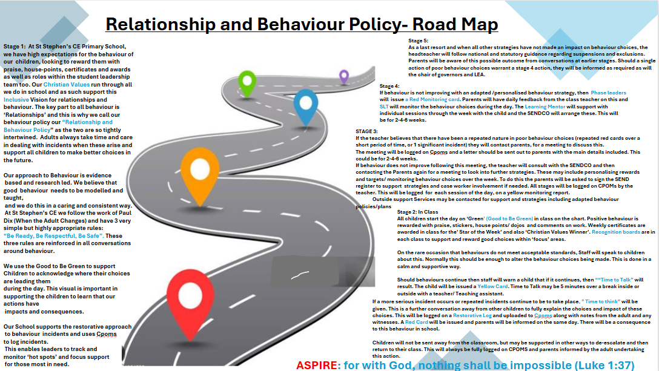

Stage 1:

Whole school principles

The key to any relationships and behaviour policy is the understanding and skill of the professionals to successfully support the needs of the child through their day. During a staff INSET (Sept 2023) a significant proportion of staff cited the relationship they have with the children as the most significant area in which St Stephen’s excels in. Using this fact therefore naturally draws the school in the direction of a ‘Relationship’ policy instead of a ‘Behaviour Policy’. This journey was started with the support and training of the Thrive approach, which will be led and rolled out across the school by the SENDCO. We are committed to ‘noticing’ children doing positive things as well as showing ‘Botherdness’.

As a school with a clear and evident Christian Distinctiveness, we promote and live the Christian Values of … in all we do.

Quality first teaching and adapted curriculums will support learning and behaviour choices in a positive way. At St Stephen’s, our staff use this as the first step in managing relationships and behaviour. Using a child’s natural enthusiasm with skillfully crafted lessons with high but manageable challenge, and targets for learning will enable less time to be ‘off task’ or concentration to drift. Where regular incidents are reported of this nature, SLT will look to support this area immediately to enable a more positive learning environment. The behaviour visual tool we deploy is called ‘Good to be Green’, which has bene adapted to meet our needs and values.

Consistency in an open and transparent approach to using any discussion or sanction are again, key to supporting this journey fully. It is vital that all adults adopt this as a personal standard and are open to developing areas of need as we expect our children and all our school community to do.Staff set high expectations for themselves and unequivocally ensure that small items are addressed immediately in a supportive and constructive manner.

We have a positive and child- centered approach to our relationship and behaviour policy and follow evidence based research (ie. EEF, Paul Dix, National online college) to do this on all occasions. We log the items outlined below with their outcomes on CPOMS to support tracking and reviewing relationships and behaviour at St Stephen’s.

Our 3 school rules are: ‘Be Ready, Be Respectful, Be Safe’.

This follows the work and research into behaviour led by Paul Dix with the key messages:

* 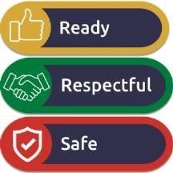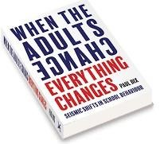Consistency is key. This means that all adults need to be on message all of the time. ...
* Naming pupils who do not behave in the way you expect does not help. ...
* Rewards are not the answer, either. ...
* Don't react emotionally to bad behaviour. ...
* Consider a 30 day rule.

We use them in ALL conversations or ‘Time to Talk’ with the child/ children.

As a Christian School we follow a restorative approach and complete a restorative log (Appendix 1) after each conversation. The person who undertakes the discussion should be the adult that initially sees the relationships and behaviour issue. It is completed and attached to the CPOMS log within 24 hours of the incident by this member of staff.

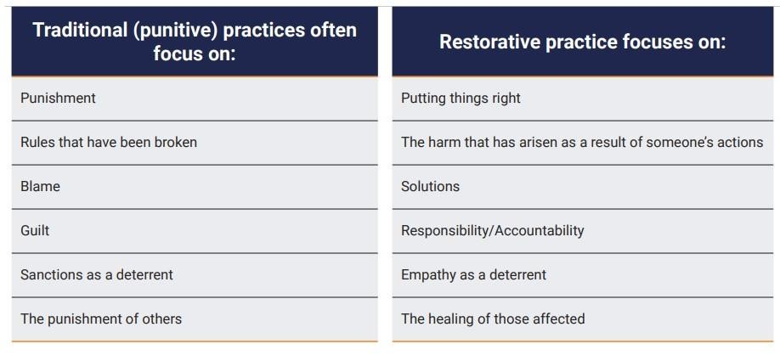A Guide to Restorative Practice

Restorative practice is an approach that aims to repair and improve relationships between members of a community. In schools, restorative practice might be used when a pupil is disruptive, breaks agreed rules, damages property or treats others inappropriately. Schools that

promote restorative practice take a positive and proactive approach to harm prevention and conflict resolution. The focus is on understanding and repairing the harm that has been caused. It can form an important part of a school’s behaviour management strategy.

What Is Restorative Practice?

Restorative schools are communities built on empathy, self-reflection and personal accountability. As the name suggests, restorative practice focuses on something being restored. For those who have been harmed, this might be:

* a feeling that their experience matters;
* a sense of justice.

For the person who has exhibited poor behaviour, the potential benefits are:

* an understanding of their impact on others;
* the opportunity to right a wrong. Communication, relationships, empathy and dignity can be developed, repaired and strengthened.

Restorative practice is sometimes referred to as a restorative approach and restorative justice. It differs from traditional approaches in a number of ways:

Issuing a sanction, such as a detention will not repair the damage caused by someone’s inappropriate behaviour. By encouraging behaviours, such as apologising, repairing items that have been broken and making amends, there is a sense of resolution.

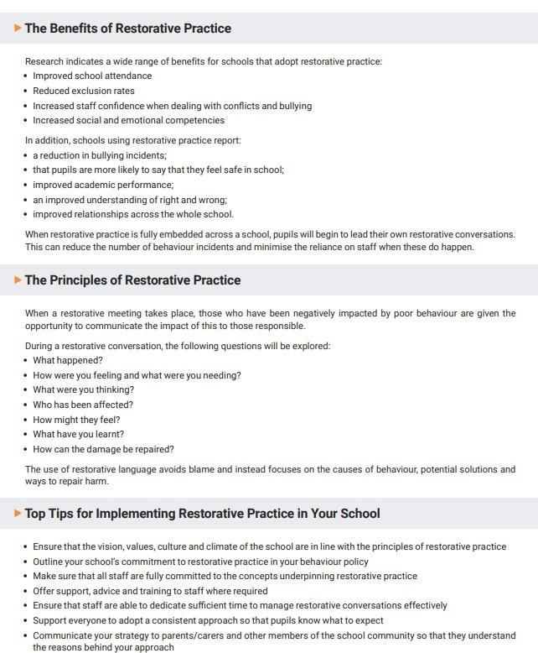

Our suggested Restorative log (a log must be undertaken and scanned into CPOMS by the teacher after each ‘time to talk’ conversation) is in appendix 1. Teachers are able to adapt these but they must cover the essential areas and be agreed by SLT.

Communication with parents/guardians will be by the person who views/ witnesses the first instance of the relationships and behaviour issue. They will also log this on CPOMS with an outcome of the conversation.

Staff are encouraged to constantly reflect and review their impact in line with all areas of their work. As such leaders are able to signpost useful evidence-based research and wider reading to support strategies and better understanding.

The most impactful person in the child’s school day is the adult team and as such they will always be fully prepared to support any needs (SEND, and others) within the class. To support this each child will be met and welcomed in at the door, along with their parents, each morning from 8.45-8.50am by the teachers (Mon/Weds/ Fri) or Teaching Assistant (Tues/ Thurs). This is another level of support and information gathering to support a key transition time for the child. It is the responsibility of the teachers/ TAs to support the transition and have strategies in place for children who need this or for when it is needed to be undertaken.

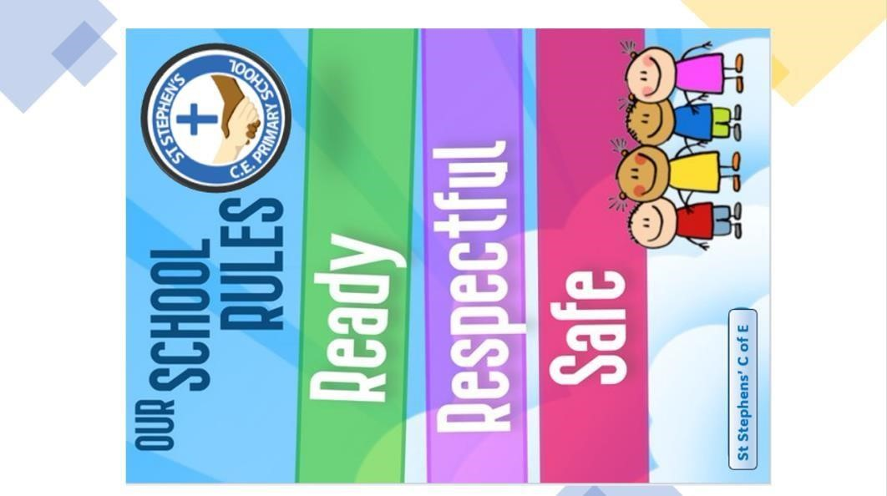Sending a child out to work elsewhere or to another member of staff/ SLT, is not a regular strategy, but a significant decision which the teacher will always consult the headteacher about. It will usually be done when the full situation (witness statements and clarifications etc) has been uploaded to CPOMS. There may be times when SLT decide a period away from the class would support either relationships or time to reflect on a particular behaviour. The class teacher will supervise appropriate, and challenging ARE and ASPIRE curriculum work to be set and a member of staff to supervise and support. This will include restorative conversations perhaps. Breaks and lunches may be taken, away from the class at this time too- again supervised and supported. This would be a short term approach (1-2days) depending upon the incident and it’s impact on others.

** SEND adaptations can also be made by the SENDCO to any part of the policy/ plans to support a child or put a strategy in place.

Using omission from trips/ sporting matches or activities will not be used as a sanction as we value each subject/ activity, teamwork, restoration, forgiveness, trust and hope at St Stephen’s. There may be the need for a risk assessment to be undertaken by the class teacher where careful consideration needs to be considered for the risk to themselves and others (including staff) of the child should they repeat those particular behaviours at the event. This needs to be signed by the Headteacher and parents on all occasions. At this point the behaviour

may be the barrier to safely undertaking an activity or taking part on the trip and the Head teacher will be consulted before the teacher works with the parent and child to find adaptations or ulterior activities to replace the trip/

visit…or part of it. The teacher will write this up in a letter and the letter be scanned to CPOMS (as all

correspondence on this level with parents are). The curriculum may need to be adapted to meet the needs of the child at times but this will be documented and be done with the supervision of the SENDCO and the knowledge of the parent and child beforehand.

EYFS will adapt the policy to follow the philosophy set out here but may have adaptations ie. Autumn term there may be several ‘re-sets’ to the cards, and form spring, this will be done at lunch each day. This will depend upon the class dynamics and appropriateness of this action in the view of the leaders of the phase.

SEND There will be a small number of children for whom any school-wide policy needs adaptation, and the relationship and behaviour policy is no different to this. The policy outlines How? When? And Why? This will be adapted as does the SEND policy.

Stage 2

Class-level management

The class teacher and team lead the relationship and behaviour policy at St Stephen’s the vast majority of the time. There will be times when a non- verbal cue is needed ie a silent action/ gesture/ teacher glance to alter a behaviour choice (appendix 2). This is best deployed as a child is demonstrating behaviour we would not expect ie. Fidgeting with stationery or not concentrating fully in class.

Staff in the room will manage and support with making better choices showing and explaining to the child ‘why?’ this matters.

Classes will use their Recognition Board (appendix 3) which is located on the class notice board for any low level but repetitive class issue. This board will focus on one item each fortnight in which children can receive positive feedback for their positive choices. The focus may be ‘WOW Walking when outside the classroom’, ‘Following the silent signals within 3 seconds’ etc. Each child will have a laminated name tag which will be moved onto the board around this core focus to show they can do it…their role and the role of the adults is to coach the others to follow this example.

YELLOW CARD: If repeated low-level behaviour persists, or a larger infraction, the teacher will perhaps instruct the child that there will be a ‘Time to talk’ set aside. This is a time where the teacher / adult supports the decision making and explores further the reason for the behaviour choices. The aim is to break down any perceived barriers and support the child into a better position to learn. Strategies will be deployed by the Teacher to do this may include moving the child to a better working position, restricting access to stationery unless it is needed, a quick task with the TA to ‘re-fresh and re-set’. This 5minute task should include a constructive and supportive conversation with the TA to enable better access to learning. At this point a yellow card will be issued after the final warning- with the clear wording that ‘ the next time …..I will issue a yellow card to you’. The yellow card cannot be rescinded.

The Yellow card leads to a ‘Time to talk’ where the adult spends time talking and supporting the child for 5-10 minutes. This is key to building empathy, relationships, trust and understanding.

Peer support, adapted curriculum support, spending time with the TA outside at break, reward etc may also be used to support a child to return to better relationship and behaviour choices.

On a very rare occasion, a single incident or a significant number of regular low-level issues may need a higher level of sanction. At this time and following the warnings set out above (if these are relevant) a red card may be issued. Staff working with the children will do all they can to understand the child and possibly the issue and positively reinforce the expected behaviour.

RED CARD: This is logged on CPOMS with all witness statements, the outcome or sanction, the report of the phone call home (done ASAP after the incident and on the same day) and the restorative log by the teacher. If a series of incidents follow each other, the first incident will take precedent. Incidents of specific concern (set out in KCSiE) ie. Protected characteristic, homophobic, Gender discrimination, sexualized behaviour/ language will always be logged against this criterion on CPOMS too.

Any sanction where a child misses a break etc must be used in a productive and restorative way with the teacher or TA and the child must be allowed a break from the classroom and to use the toilets etc if needed. Tasks like writing the restoration cards out in a handwriting book are acceptable. The child is to be supervised by a member of the class team at all times. This time to talk is vital in understanding the needs and perspective of the child and reflecting if things could have been done differently.

Stage 3:

Monitoring of relationships and behaviour

If repeated red cards are accumulated over a short period of time (and the stages 1 and 2 have been reviewed by the teacher and SLT) the teacher will speak with the Behaviour lead and parents to ask for support in issuing a monitoring card (appendix 4). These will be yellow and red and be progressive steps to again support the child. If a monitoring card is chosen as the appropriate route, The teacher will contact the parents to explain:

1 the reason for their decision and that this is a step up in the policy as an additional measure 2 The length of the monitoring card

1. the process (signed daily by school , child and parent/ guardian)
2. the strategies being put into place by the teacher for all parts fo the day
3. the teacher will explain that they will scan and log the monitoring card onto CPOMS. The teacher will enquire and log any concerns at home and offer support via early help or CAMHS

If directed, the teacher will engage with the SENDCO or Behaviour lead to ensure appropriate strategies are put into place for the daily routine of the child (Appendix 5). This is the stage where the SENDCO will more often than not, be invited into the support. The SENDCO and Class teacher will meet as a matter of urgency with the parent/ guardian and ask that the SEND register is signed and support / strategies are deployed from outside professionals to support the child. These will be written up, put into place and monitored by the SENDCO on a weekly basis.

Stage 4:

SLT- RED Monitoring Card

If repeated yellow monitoring card does not support the initial concern or behaviour which led to the yellow monitoring card (children, like adults, will behave across a range of relationship and behaviour spectrums), then the class teacher will request a meeting to discuss escalation to a Red monitoring card.

If this is agreed, SLT will meet with the teacher, child and home to initiate the card and a letter will be written home to support the agreement of this step.

Breaks and Lunch will be spent with an adult each day and a member of SLT will check in over the day to discuss positive behaviour or praise for good choices. The teacher will inform the parents each day of the positive behaviour seen ad key events so that they are informed. Support and strategies from the learning mentor and SENDCO/ support services will be planned and put into place by the class teacher, and monitored by the SENDCo/ SLT each week.

Stage 5:

The route to suspension/ exclusion

There may at times be the need for the child to work away from the class – but these will be following a ‘crisis’ point has bene reached. Time needs to be spent firstly supporting the child back down to a zone of better regulation ie. Library area before reviewing the behaviour and restoration log etc. Also, time needs to be spent reviewing the incident and stages of escalation/ flashpoint. By the adults. These times will be recorded on CPOMS and contact with home will be made by the teacher or adult who first becomes involved with the child’s relationship and behaviour incident.

If significant issues arise repeatedly there will be a meeting between the teacher, child’s parent/ guardian, the child and Headteacher. At this point the risk of suspension will be noted and followed up in a letter. A agreed contract for behaviour and rewards will be put into place. St Stephen’s will do all it can to support the child and family even if this should be to work with the LEA support team with outside bodies or schools for the best interest of the child.

The most recent Government and LEA guidance will be used when this is the case, and a child is at risk of exclusion. <https://www.gov.uk/government/publications/school-exclusion>

Positive handling:

Positive Handling is a system of safe holding techniques, used as a last resort when de-escalation skills have failed, where staff safely support pupils to move to a safe/ less disruptive space, until they can hold their own emotions, and by doing so prevent them harming themselves or others. Positive handling will be used by trained staff if available and this will be logged on cpoms and parents informed. Two adults will be present at all times.

Supervision support will be in place following this strategy. Log of the event will be made and kept on CPOMS with the DSL informed immediately

Banned items , searches and confiscation:

Staff members have the power to search pupils for any item if the pupil agrees, under the common law (paragraph 4 of the DfE guidance). The DfE told us that how this applies to a particular case will depend on the situation and your school policy

Only the headteacher and members of staff authorised by the headteacher have the power to search a pupil for a prohibited or banned item, regardless of whether the pupil agrees (sections [550ZA and 550ZB o](https://www.legislation.gov.uk/ukpga/1996/56/chapter/II/crossheading/powers-to-search-pupils)f the

Education Act 1996, and paragraph 10 in the guidance). Your policy should set out which items can be searched for (read more about prohibited and banned items below)

This is outlined in paragraphs 2, 4 and 10 of the [DfE’s guidance on searching, screening and confiscation.](https://www.gov.uk/government/publications/searching-screening-and-confiscation)

Even though common law sets out that any staff member can conduct a search with the pupil's permission, it's best practice to only allow staff members who have been authorised by the headteacher to conduct searches.

This advice comes from [Forbes Solicitors,](https://www.forbessolicitors.co.uk/secure/business/enquiry.htm?pa=27) and is outlined in ‘The Key’.

The headteacher can:

* Authorise members of staff to search for specific items (e.g. alcohol only), or all banned items
* Require a security staff member (including those who aren't school staff) to conduct a search

Under law:

* The person carrying out the search must be the same sex as the pupil being searched
* There must be another member of staff present as a witness to the search The only exception to this is if:
* The searcher reasonably believes that there is a risk of serious harm being caused to a person if a search isn’t carried out urgently and
* It's not reasonably practical to summon another member of staff (to carry out the search or act as a witness) within the time available

The member of staff witnessing the search must also be the same sex as the pupil being searched if this is reasonably practicable ([paragraph 6(d) o](https://www.legislation.gov.uk/ukpga/1996/56/chapter/II/crossheading/powers-to-search-pupils)f section 550ZB of the Education Act 1996) .

When an authorised staff member conducts a search without a witness, they should immediately report it to another member of staff, and make sure that a record is kept.

What you can search for

Headteachers and authorised staff members can search a pupil for:

* Any items with the pupil's informed consent
* Prohibited or banned items, with or without the pupil's consent

Prohibited items are:

* Knives or weapons
* Alcohol
* Illegal drugs
* Stolen items
* Tobacco and cigarette papers, ECigs/Vapes, Lighters/ matches.
* *Electronic devices including phones/ tablets/ cameras/ smart watches
* *Jewellery
* Fireworks
* Pornographic images
* Any article that the member of staff reasonably suspects has been, or is likely to be, used to: o Commit an offence

o Cause personal injury (including the pupil) or damage to property o *Cause disruption to the good order of the school / lessons/ concentration

This list is set out in [The Education Act 1996 a](https://www.legislation.gov.uk/ukpga/1996/56/section/550ZA)nd paragraph 3 of the DfE's guidance on searching, screening and confiscation.

Other items banned by school *In addition to the list above, headteachers and authorised staff members can also search for other specific items banned in school.

Appendix 1: Restorative Log

[https://nationalcollege.com/webinars/taking-a-restorative-approach-to-create-peacefullearning-environments-i-](https://nationalcollege.com/webinars/taking-a-restorative-approach-to-create-peaceful-learning-environments-i-primary?play=true)

[primary?play=true](https://nationalcollege.com/webinars/taking-a-restorative-approach-to-create-peaceful-learning-environments-i-primary?play=true)

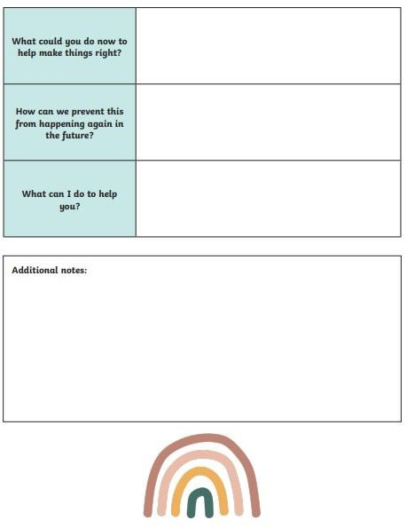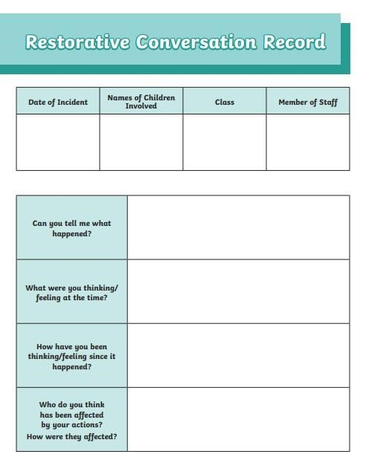

Signed (child)

Signed (Adult)

** ADULT TO LOG AND THEN SCAN THIS ON CPOMS **

More serious incidents will need witness statements too

Appendix 2: St Stephen’s Silent Signals

Silent signals

Praise children for routines they do quickly and quietly. However, once children know the routines, acknowledge their co-operation with a nod, a smile or a thank you.

|  |  |  |
| --- | --- | --- |
| Sign | Name | Description and purpose |
|  | Stop sign | The team stop signal helps us stop children in a calm manner, ready for what’s next. It replaces all other stopping techniques: clapping, clicking, singing rhymes, shaking a maraca, shouting, shushing, singing, dance routines, counting back.  The stop signal is used at playtime, in assembly, in lessons, during transitions, at lunchtime, on trips and in staff meetings.  Use this signal to gain attention. Practice until children respond in under five seconds and in silence.    1. Hold one hand in the air with a flat palm. Do not clap or talk. 2. Scan the room to check every child has responded.  Every child:   * Raises one hand in response; * Checks their partner and others at their table have also raised their hands – gently tapping an arm if necessary; * Looks attentively at you – eyes locked into yours to show they are ready to listen; * Sits up tall, beside their partners.   3. Lower your hand and scan to check everyone is looking at you attentively, ready to listen. Do not start talking until you have their attention.    If someone is still talking or not sat/stood ready and giving eye contact with their arm raised, a gentle shoulder tap by the person next to them is undertaken to notify them of this sign. |
|  | **Turn to your**  **partner**    **(TTYP) signal** | Partner work should be used consistently in all lessons. Hold both hands pointing forward as if they are two open gates. Close the gates as soon as you have finished asking the question.  Practice this signal until children turn automatically to their partners to answer the question. Avoid saying the words ‘turn to your partner’.    Children should turn their heads towards their partners, not their whole body or chair. |

|  |  |  |
| --- | --- | --- |
|  | **My Turn,**  **Your Turn**    **(MTYT) signal** | Use this silent signal when you want the children to repeat something after you.  My turn: gesture towards yourself with one or two hands. Your turn: gesture towards the children with one or two open palms.  Explain to the children that this signal is yours and not theirs. |
|  | **Magnet eyes** | When you want to be sure the children are listening, point to your eyes with two fingers.  This indicates that their eyes should be on yours and their bodies still. |
|  | **1, 2, 3 signal** | Move the children silently from carpet to table in under 15 seconds.  Hold up one finger: children stand  Hold up two fingers: children walk and stand behind their chairs  Hold up three fingers: children sit down and prepare to read or write.    And in reverse, move the children from table to carpet in under 15 seconds.  Hold up one finger: children stand behind their chairs  Hold up two fingers: children walk to carpet  Hold up three fingers: children sit down beside their partners. |
|  | **Silent Perfect**  **writing position** | Once children are sitting at their tables, hold up a pencil – real or imaginary – in a pencil grip with the non-writing hand flat – holding imaginary paper.  This signal indicates that children sit with their:   * feet flat on the floor bottom at the back of the chair body one fist gap, from the table * shoulders down and relaxed * Left/right hand holding page * back leaning forward slightly * left/right hand holding a pencil, ready in tripod grip. |

Appendix 3: Recognition Board



Stuck to the main whiteboard at the front of the class and has a weekly focus where positive reinforcement is always used. Names are added through the day/ week as children achieve the focus….”Following silent signals” etc.

Appendix 4: Monitoring Card

* these are likely to be individualized and based on achieving a score each lesson inc. break times for an agreed ‘incentive’ . the teacher and SENDCO plan these immediately so they are in place to support positive choices.
* These will be agreed with SENDCO and parents before use ( this conversation and the behaviour plan will be logged on CPOMS by class teacher) Parents to sign each night to say they have read and heard feedback from the TA and teacher.
* Probably a 1-2 week period. With clear expectations for the behaviour expected , with support in place and resources used- these are set out on the card

Appendix 5: Individual Behaviour Plan

* these are likely to be individualized and based on achieving a score each lesson inc. break times for an agreed ‘incentive’
* These will be agreed with SENDCO and parents before use ( this conversation and the behavior plan will be logged on CPOMS by SENDCO)
* With clear expectations for the behaviour expected, support in place and resources used is set out on the card . These may stay longer for children with needs if it is believed the behaviour and relationship olicy does not meet a child’s needs. This will be done via the SENDCO. Movement to stage 5 could still occur if behaviour falls short of the standards expected at the school.