

|  |
| --- |
|  |

Parent code of conduct

|  |  |  |
| --- | --- | --- |
| **Approved by:** | Governors | **Date:** 23/11/23 |
| **Last reviewed on:** | November 2023 | |
| **Next review due by:** | November 2025 | |

At St Stephen’s CE Primary School, our Christian values run through our school like a golden thread and enable our children to flourish and ASPIRE in life. Our Christian vision: *for with God, nothing is impossible* Luke 1 : 37, helps support and guide our whole school community in striving to beat our previous best endeavours.

Throughout the year, we re-focus on a Christian Value in order to keep God in the centre of our lives. By linking these to key events within the Christian calendar our children will all take turns in leading key collective worships for our whole school community at St Stephen’s Church, once a year.

|  |  |  |  |  |  |
| --- | --- | --- | --- | --- | --- |
| Autumn 1 | Autumn 2 | Spring 1 | Spring 2 | Summer 1 | Summer 2 |
| Thankfulness | Respect | Hope | Forgiveness | Love | Trust |

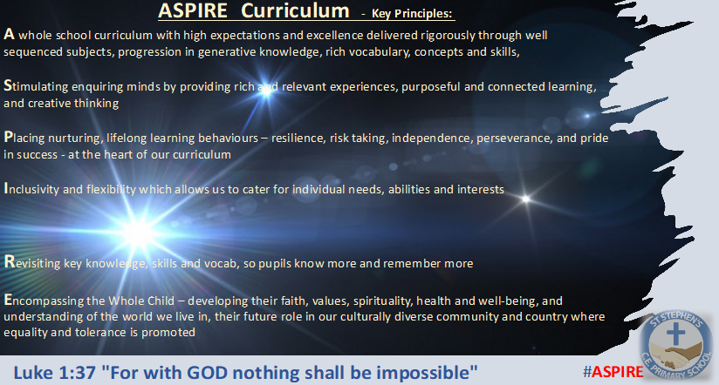

The key principles of our ASPIRE vision support our decision-making process at St Stephen’s CE Primary School for the curriculum. With these principles in place, our children are able to know more and remember more across development of our broad and balanced curriculum.

**Contents**

1. Purpose and scope 3

2. Our expectations of parents and carers 3

3. Behaviour that will not be tolerated 4

4. Breaching the code of conduct 3

Appendix 1: model letters 4

Initial warning letter from the headteacher 4

Model letter banning a parent from the school site  5

# 1. Purpose and scope

At St. Stephen’s, we want everyone to be the best that they can be – with God’s help. In this endeavour, we believe it’s important to:

* Work in partnership with parents to support their child’s learning and development at all times
* Create a safe, respectful and inclusive environment for pupils, staff and parents
* Model appropriate behaviour for our pupils at all times

To help us do this, we set clear expectations and guidelines on behaviour for all members of our community. This includes staff (through the staff code of conduct) and pupils (through our behaviour policy).

This code of conduct aims to help the school work together with parents by setting guidelines on appropriate behaviour.

We use the term ‘parents’ to refer to:

* Anyone with parental responsibility for a pupil
* Anyone caring for a child (such as grandparents or child-minders)

# 2. Our expectations of parents and carers

In common with our staff and children, our expectations of our parents and carers are high. We expect parents, carers and other visitors to:

* Respect the ethos, vision and values of our school and to fully support it’s aims at all times. This means in person, online and whilst communicating about the school and it’s stakeholders
* To model, uphold and support the school in implementing it’s policies, values and aims at all times
* Work together with staff in the best interests of our pupils
* Treat all members of the school community with respect – setting a good example with speech and behaviour
* Seek a peaceful solution to all issues with honesty and integrity and speaking to us first to allow us to find solutions to support the children/ school
* Correct their own child’s behaviour appropriately (or those in their care), particularly in public, where it could lead to conflict, aggression or unsafe conduct
* Approach the appropriate member of school staff directly in the first instance to help resolve any issues of concern. This will usually be the class teacher.

# 3. Behaviour that will not be tolerated - these actions/ words includes those being used or sent in messages or online.

# \*\***This is list is not exhaustive**

* Disrupting, or threatening to disrupt, school operations (including events on the school grounds and sports team matches , or online of any form)
* Swearing, or using offensive language or speaking in an aggressive manner towards any member of the school community
* Displaying a temper, or shouting at members of staff, pupils or other parents
* Threatening another member of the school community
* Indulge in gossip about another parent, member of staff or child
* Sending abusive messages to another member of the school community, including via text, email or social media
* Posting comments , including negative, defamatory, offensive or derogatory comments about the school, its policies or practices, its staff or any member of its community, on social media platforms. This includes ‘liking’ or other forms of social media ‘language/ icons’
* Not supporting the decisions of the school or requests of the school
* Use of physical punishment against any child while on school premises
* Any aggressive behaviour (including verbally or in writing) towards another child or adult
* Disciplining another person’s child – please bring any behaviour incidents to a member of staff’s attention
* Smoking, vaping or drinking alcohol on the school premises (unless alcohol has been allowed at a specific event)
* Possessing or taking drugs (including legal highs)
* Use of mobile phones when asked not to due to safeguarding protocol ie on school site
* Sharing photographs of children other than your own in a way which makes them or the school identifiable
* Bringing dogs onto the school premises (other than guide dogs with permission)

# 4. Breaching the code of conduct

If the school suspects, or becomes aware, that a parent has breached the code of conduct, the school will gather information from those involved and speak to the parent about the incident.

Depending on the nature of the incident, the school may then:

* Send a warning letter to the parent
* Invite the parent into school to meet with a senior member of staff or the headteacher
* Contact the appropriate authorities (in cases of criminal behaviour)
* Seek advice from the Local Authority’s legal team, regarding further action (in cases of conduct that may be libellous or slanderous)
* Ban the parent from the school site

The school will always seek to respond to an incident in a proportional way including through legal and police channels. The final decision for how to respond to breaches of the code of conduct rests with the headteacher.

The headteacher will consult the chair of governors before banning a parent from the school site.

# Appendix 1: model letters

### Initial warning letter from the headteacher

Dear [parent name],

I’ve received a report about your conduct on [time and date].

[Summary of incident, include location, its effect on staff, pupils and other parents.]

If the incident is minor, add:

This behaviour is not in keeping with our parent code of conduct. [Please find a copy attached to this letter.]

If the incident is more serious, add:

As written in our parent code of conduct, we do not tolerate this kind of behaviour in our school. [Please find a copy attached to this letter.]

We believe that all staff, pupils and parents are entitled to a safe, respectful and inclusive environment, and that parents are as responsible for creating this environment as school staff. The Chair of Governors has been made aware of this incident.

Continue with:

Further breaches of the code of conduct may result in a ban from the school premises.

If you want to invite the parent in for a meeting, add:

I’d like to invite you in to school to discuss this incident, and how we can work together to prevent similar issues in the future.

Please contact the school office on [phone number] to book an appointment.

Yours sincerely

Headteacher

### Model letter banning a parent from the school site

Dear [parent name],

I am writing to inform you that, after consultation with the Chair of Governors, I am banning you from the school site until [date].

You can also choose to ban a parent permanently. In that case, amend the sentence above.

Despite previous correspondence and conversations about your conduct, there have been further breaches of our parent code of conduct.

[Include details of the incidents, including dates, locations and effects on staff/pupils/other parents for every relevant incident.]

If you do not comply with the ban, I will arrange for you to be removed from the grounds and you may be prosecuted under Section 547 of the Education Act 1996.

If you would like to raise a complaint, you can do so using the school’s complaints procedures, which are available on our website.

Yours sincerely

Headteacher

### 