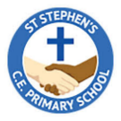

**Year 5 Curriculum Overview**

Autumn 1 2024

**SCIENCE**This half term we will be focusing on properties and changes of materials.

* Cooling and heating materials
* Particle properties
* Three states of matter

**P.E.** This half term, the children will be having a PE lesson on a Monday and also on a Thursday. Please ensure children come to school in the correct PE for both days.

**ENGLISH**

This half term, we will be completing a range of non-fiction, fiction and poetry writing based on our new book ‘Winters Child’. We will be using this book to inspire their imagination.

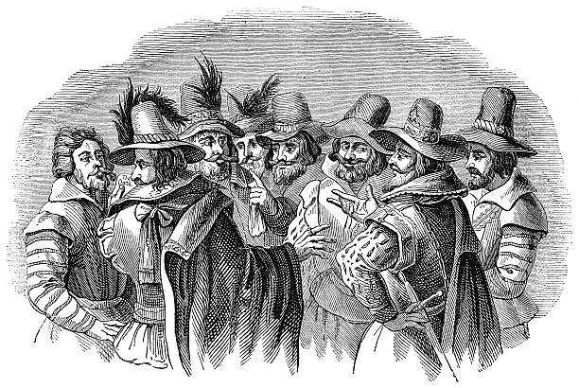

**MATHS**In Maths, we will begin looking at place value:

* Numbers to 10,000
* Roman numerals
* Round to the nearest 10, 100 and 1,000
* Compare and order numbers
* Negative numbers
* Rounding to 1 million.

**HISTORY**

In History, we will be learning about the Gun powder plot and behind the reasons why they wanted to do and why the plot failed. We will also find out why we remember the 5th of November.

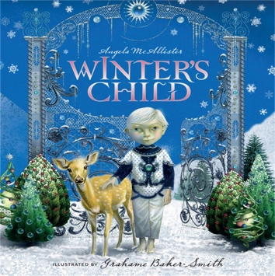

**R.E.**In RE, we will be looking at the meaning of Christians believing God is loving and Holy.

**FRENCH**In French, we will be learning about places and how to use directions to get there.

**PSHE**In PSHE, we will be looking at ‘Being Me in My World’. Focussing on values and responsibilities we have.

**ART:**

In Art, we will be developing our painting and mixed media skills using artists studies.

**MUSIC:**

In music, we will be learning how to sing and play an instrument to ‘Living on a prayer’ by Bon Jovi

**MUSIC**

We will be learning about rhythm and music notation.