# 

**Year 3 Curriculum Overview**

Spring 1 2025

**SCIENCE 🦴🦴**This half term we will be continuing our unit on ‘Animals Including Humans – Nutrition and the Human Skeleton’. End of topic expectations include: I can talk about what animals and humans need to stay healthy, showing a basic understanding of healthy eating. I can name and briefly describe the different types of skeletons. I can match labels to some parts of the human skeleton. I can explain in a basic way how some muscles work.

**MUSIC 🪕**

Year 3 will continue to receive ukelele lessons from the Music Teacher from Tameside Music Service.

**ENGLISH**In English we will be reading a new class book called ‘Emily Brown and the Thing..’ We will study the structure of the story and use it as a starting point to create our own story in a familiar setting.

Pupils will retell the story using a story map and make word and vocabulary banks of verbs, adverbs and noun phrases to use in their own version of the story. We will also be creating a set of instructions and a recount to develop our writing skills further.

How did metal change the way we live?

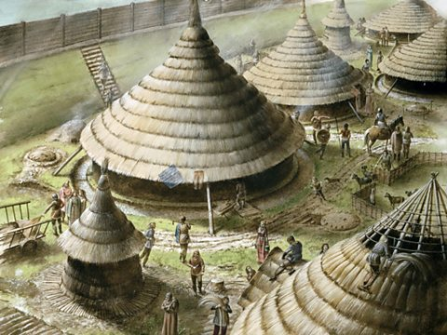

**PSHCE – Dreams and Goals**We will learn about specific people who overcame challenges and discover what dreams are important to them. We will then reflect on how we are responsible for our own learning and what are strengths.

**History**. “How did metal change the way we live?”

We will continue our learning about prehistoric Britain, focusing on the changes during the Bronze Age and the Iron Age.

**MATHS**In Maths we will be continuing our learning about Multiplication & Division, following that we will be learning about length and perimeter.

We will also be practising our times tables weekly and also our arithmetic skills, involving all four operations. We will develop our measuring skills to help us solve problems including perimeter.

**FRENCH – ‘All About Me’**

We will continue our learning of the French words for parts of the body, colours, numbers and clothes.

**COMPUTING** Programming

We will be learning about using a programming environment, which will be new to most of us. We will be introduced to a selection of motion, sound, and event blocks which we will use to create their own programs, featuring sequences. The final project is to make a representation of a piano.

**R.E. - “What kind of world did Jesus want?”**

We will be learning about Christian beliefs about what Jesus taught and how we see them in our school values.

**P.E. 🏀**We will continue to develop our skills in outdoor games to help improve our passing and movement. We will also develop our gymnastic skills. **PE will be Mon and Weds!**

**Art – ‘Painting and Mixed Media’**

We will be recreating the style of cave artists using charcoal and natural pigments.

**MUSIC**

We will be learning about rhythm and music notation.

😁 Y3 homework is reading, spelling practice and times tables or number bonds practice. 😊