Uniform Policy



September 2024

Reviewed in Jan 2025

At St Stephen’s CE Primary School, our Christian values run through our school like a golden thread and enable our children to flourish and ASPIRE in life. Our Christian vision:

for with God, nothing is impossible Luke 1 : 37, helps support and guide our whole school community in striving to beat our previous best endeavours.

Throughout the year, we re-focus on a Christian Value in order to keep God in the centre of our lives. By linking these to key events within the Christian calendar our children will all take turns in leading key collective worships for our whole school community at St Stephen’s Church, once a year.

|  |  |  |  |  |  |
| --- | --- | --- | --- | --- | --- |
| Autumn 1 | Autumn 2 | Spring 1 | Spring 2 | Summer 1 | Summer 2 |
| Thankfulness | Respect | Hope | Forgiveness | Love | Trust |



The key principles of our ASPIRE vision support our decision-making process at St Stephen’s CE Primary School for the curriculum. With these principles in place, our children are able to know more and remember more across development of our broad and balanced curriculum.

School uniform encourages a sense of identity, pride and responsibility. We are grateful for your support in ensuring our scholars represent themselves, their families and their school to the best of their ability. If you need support in the buying of uniform, please do come and speak with us, or alternatively call the school office on 0161 286 330 3818

We will ask children to come into school, in their PE kits (with sensible coats etc too) on their PE days.

Please note that it is NOT compulsory to wear items with the school logo. Many of the items below can be bought at most supermarkets, which can often be more cost effective.

Polo necks, school fleeces, cardigans and polo shirts with the school logo are available from www.stitchdesign.co.uk or ‘Top Marks Schoolwear’ in Ashton-under-Lyne.

# RECEPTION – YEAR 5

* Royal blue crew neck sweatshirt, school fleece or cardigan
* Yellow polo shirt
* Dark Grey trousers, shorts, skirt or pinafore dress
* Yellow or blue gingham summer dress
* Black/grey/white socks or grey tights
* Black school shoes or boots (that can be polished) – no trainers, please see below for examples.
* No make up or jewellery (this included nail varnish)
* One small pair of stud earrings (plain in colour and design). The child must be able to remove these for PE – plasters to cover are not sufficient. We ask all parents to consider ears being pierced during the summer holidays to avoid issues in school times.

# YEAR 6

* Royal blue V-neck sweatshirt, school fleece or cardigan
* School tie – please contact the school office if you need a replacement
* White shirt or blouse(short or long sleeved) with collar
* Dark Grey trousers, shorts, skirt or pinafore dress
* Yellow or blue gingham summer dress
* Black/grey/white socks or grey tights
* Black school shoes or boots (that can be polished) – no trainers, please see below for examples.
* No make up or jewellery (this included nail varnish)
* One small pair of stud earrings (plain in colour and design). The child must be able to remove these for PE – plasters to cover are not sufficient. We ask all parents to consider ears being pierced during the summer holidays to avoid issues in school times.

# PE KIT – all children

• White T-shirt, black shorts/leggings, PE pumps for indoor PE, trainers for outdoor PE. A tracksuit (or separate jogging bottoms and a hoodie) for when children do PE outside in colder weather

PE kit is a vital part of our school uniform. Children with long hair must be able to tie it back for PE (if it can be tied back …it Must be tied back) and those children with earrings must be able to take them out themselves on PE days- studs (even covered with plasters) are not acceptable

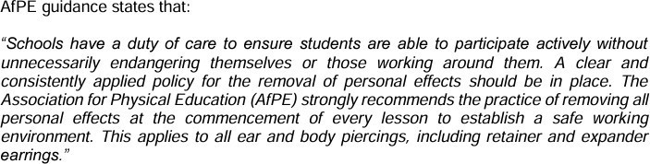

# JEWELLERY & ACCESSORIES

* Small, plain Stud earrings only on non- PE days, which must be able to be removed by the child for PE . Children are responsible for keeping these safe
* No rings, necklases or bracelets
* Long hair must be tied back/ up sensibly with a plain bow (s)
* Watches are allowed but must be removed for PE. SMART watches or Fitbits are not allowed
* Hair bobbles/Alice bands should be plain or a blue/yellow gingham ‘scrunchy’
* Socks with yellow or blue gingham or white frills are permitted
* Book bags with the school logo are available from school but must be paid for online via SIMSpay prior to collection.

