**

**Year 5 Curriculum Overview**

Spring 1 2024

**P.E.** This half term, the children will be having a PE lesson on a Monday and on Friday which will be swimming. Information about swimwear will be in our Year 5 letter.

**SCIENCE**This half term we will be focusing on Earth and Space looking at the movement of the earth and the planets and how the moon moves around.

**ENGLISH**

This half term, we will be completing a range of writing based on our book for hook **‘Jumanji’**.

**HISTORY**

This half term in history we will be learning about Anglo – Saxon and Scots and their invasion of Britain when they settled.

**MATHS**In Maths, we will be looking at:

-Multiplication and division (Multiplying 3 digits by 2 digits and 4 digits by 1 digit, dividing using different methods with remainders)

-Fractions (non-unit and mixed number fractions with integers)

- Perimeter and area (with different shapes)

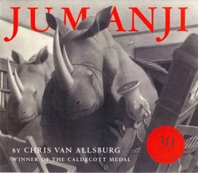

**MUSIC**

We will be learning about rhythm and music notation.

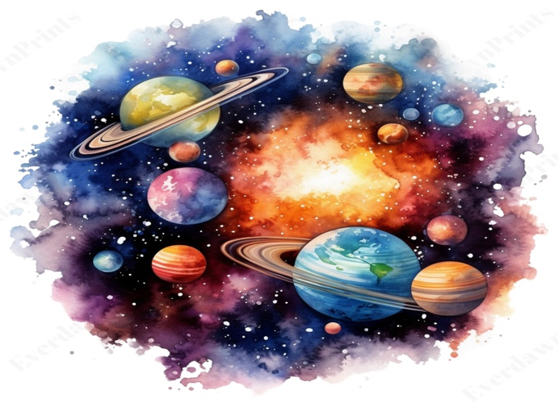

**FRENCH**In French, we will be looking at food and drink and how we can describe what we are eating and would like to eat in French.

**PSHE**In PSHE, we will be looking at our dreams and goals and how we can support each other to get to these goals.

**ART**

In art this term we will be looking at drawings and specifically how every picture tells a story.

**R.E.**In RE this term, we will be looking into how Christians decide how to live and what would Jesus do?

**MUSIC**

In music, we will be looking at the history of music styles focusing on the song ‘Make you feel the love’.