


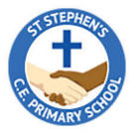
Year 3 Curriculum Overview
Autumn 2

English –
Our ‘book for hook’ for this half term is ‘Herb the Vegetarian Dragon. We will use the structure of the story to write our own narratives based on the text. Following this, we will write instructions applying a range of Year 3 grammatical features.

Maths-
We will begin the half term recapping multiplication and division of the 2-, 5- and 3-times tables. We will then begin to apply our understanding of multiplication and division calculation methods to the 4 and 8 times tables.
Herb the vegetarian Dragon
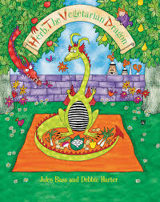

PE:
PE will be taught on Monday and Friday. Please make sure children come to school in their PE kits on these days as per our PE policy.
Geography-
Our enquiry question is ‘Should we climb every mountain?’. We will be learning about how mountains are formed, their features and locating them on maps and atlases.

RE-
Our ‘big question’ this half term is ‘What do Hindus believe God is like?’. We will explore the different Gods of the Hindu religion and learn about symbols and ways of life and how they differ to Christianity.

Science-

This half term we will be learning about animals and humans. We will begin the unit by exploring nutrition in food groups and then learn about different skeletons and how our muscles work.

PSHCE-
We will be exploring rules and why they are needed, consequences and the effects our actions can have on others.
French-
We will be learning basic language and terms to describe our body parts, colours and classroom instructions.
DT-
We will be developing design and understanding of 3D structures by making castles that are strong and stable.
Music-
Year 3 will continue with their ukulele lessons on a Thursday afternoon. The focus will be on playing notes in time and sequence.

