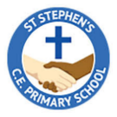

**Year 3 Curriculum Overview**

Autumn 1

**English –**

Our ‘book for hook’ for this half term is ‘Stone Age Boy’. We will use the structure of the story to write our own stories based on time travel. Following this, we will write reports based on our learning in history.

**Maths-**

We will begin the half term recapping and exploring numbers and place value within 1000. Following this, we will practise methods for column addition and subtraction.

Stone Age Boy

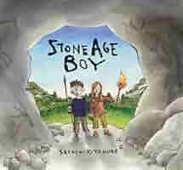

**PE:**

PE will be taught on Monday and Wednesday. Please make sure children come to school in their PE kits on these days as per our PE policy.

**History-**

Our enquiry question is ‘How did early man live?’. We will be learning about the Stone Age and ways of life during this period.

**RE-**

Our ‘big question’ this half term is ‘What do many Christians learn from the creation story?’. We will explore the story in detail and consider its implications on Christian life and how we care for our world.

**PSHCE-**

We will be exploring rules and why they are needed, consequences and the effects our actions can have on others.

**Science**-

This half term we will be learning about light. We will explore sources of light, how light is reflected from surfaces and how to make and change the shape and size of shadows.

**French-**

We will be learning how to greet people in French and ask and answer basic questions to get to know others.

**Art-**

We will be developing our drawing skills, leaning how to add texture and tone, and creating scaled drawings using view finders.

**Music-**

Year 3 will be taught music by a specialist music teacher this half term, leaning how to play ukuleles.