COMPUTING POLICY

At St Stephen’s CE Primary School, our Christian values run through our school like a golden thread and enable our children to flourish and ASPIRE in life. Our Christian vision: ‘for with God, nothing is impossible’ ( Luke 1 : 37), helps support and guide our whole school community in striving to beat our previous best endeavours.
Throughout the year, we re-focus on a Christian Value in order to keep God in the centre of our lives. By linking these to key events within the Christian calendar our children will all take turns in leading key collective worships for our whole school community at St Stephen’s Church, once a year.

Autumn 1 | Autumn 2 | Spring 1 | Spring 2 | Summer 1 | Summer 2
Thankfulness | Respect | Hope | Forgiveness | Love | Trust

The key principles of our ASPIRE vision support our decision-making process at St Stephen’s CE Primary School for the curriculum. With these principles in place, our children are able to know more and remember more across development of our broad and balanced curriculum.

Luke 1:37 "For with GOD nothing shall be impossible”

What is Computing?
Introduction
A high-quality computing education equips pupils to use computational thinking and creativity to understand and change the world. Computing has deep links with mathematics, science, and design and technology, and provides insights into both natural and artificial systems. The core of computing is computer science, in which pupils are taught the principles of information and computation, how digital systems work, and how to put this knowledge to use through programming. Building on this knowledge and understanding, pupils are equipped to use information technology to create programs, systems and a range of content. Computing also ensures that pupils become digitally literate – able to use, and express themselves and develop their ideas through, information and communication technology – at a level suitable for the future workplace and as active participants in a digital world.
Aims
The national curriculum for computing aims to ensure that all pupils:
- can understand and apply the fundamental principles and concepts of computer science, including abstraction, logic, algorithms and data representation▪
- can analyse problems in computational terms, and have repeated practical experience of writing computer programs in order to solve such problems
- can evaluate and apply information technology, including new or unfamiliar technologies, analytically to solve problems
- are responsible, competent, confident and creative users of information and communication technology.

Intent
The Computing curriculum at St Stephen’s CE intends to inspire a curiosity and fascination about the world in which we live in. We will equip the children with knowledge about diverse places, people, resources and natural and human environments, together with a deep understanding of the Earth’s key physical and human processes. We have created a bespoke curriculum in Computing, focusing on map skills, global issues and contrasting localities around the world. The children will benefit from finding out about their local environment in relation to our country, continent and the world around them. In our Computing teaching, we will provide the children and parents with opportunities to experience and gain an interest in their immediate world and how this impacts on the wider world.
At St. Stephen's, we use the 'Teach Computing' Scheme of Work from the National Centre for Computing Education to deliver a comprehensive and structured Computing curriculum. This scheme provides clear progression and high-quality resources, ensuring that our lessons are engaging and effectively support the development of essential computing skills. By aligning with the latest educational standards and best practices, we ensure that our pupils receive a robust foundation in computer science, digital literacy, and information technology. The rationale for using this scheme lies in its flexibility and inclusivity, allowing us to cater to the diverse needs of our students while fostering creativity, problem-solving, and critical thinking skills essential for their future success in a technology-driven world.

Best practice in Computing, including quality examples of expectations are shared with teaching and support staff, prior to their teaching of Computing. The document ‘What does best practice in Computing look like?’ can be found on the school’s shared drive, always available for teaching and support staff to access.
At the end of each unit, the children are assessed by the class teacher using the Impact task outlined in the MTP. These assessments are collated on the assessment document for each class. This document is then used over the academic year to build up a clearer picture for the teacher, who at the end of the year will undertake a 'best fit' analysis along with using their teacher judgement to give a final assessment grade for each member of the class. These are reported and logged on the assessment sheet and the child's end of year written report. At the end of each unit any 'gaps' are logged which are then addressed in subsequent weeks and unit to ensure that no gaps in 'Key Knowledge, Skills or Vocabulary' are left. This gaps analysis will only be brief but will ensure that:
- the initials of the children with gaps are logged,
- what those gaps are, and
- when they are to be addressed.
Addressing these gaps does not just have to wait until the next unit of teaching. They can be supplementary tasks which can be done with support at home (these can often be skills or learning vocab effectively), sessions with the class TA during pockets of time during the day ie. a timeline activity, or perhaps revisited in other areas of the curriculum (ie map reading with co-ordinates and maths).
The key to retaining knowledge is to not allow it to be missed or allow gaps to grow over time. In this way we strive to develop lifelong skills and knowledge throughout the Aspire curriculum at St Stephen’s CE.

Implementation
Computing will be taught for every half term each year. The objectives are taken directly from the National Curriculum. We revisit these objectives to support retrieval of the knowledge gained and build on and consolidate learning. The subject leader, alongside class teachers and the Curriculum lead have developed a bespoke curriculum, personal to the children from our school, to ensure breadth and coverage.
The children will have a knowledge organiser at the beginning of each topic, to show the specific geographical knowledge that they will learn throughout the topic. Points/places of interest (e.g. maps, landmarks, features) will be signposted and key vocabulary for that topic will also be present. This will enable the children to recall key facts about Computing during the topic and is a document that the children can refer to in their learning. This will be stuck into their Computing books. The knowledge organiser will also be added to the website for each year group so that parents can access this and encourage their children to deepen their knowledge outside of school.
The lessons in the medium term plan have been sequenced to ensure that;
In Key Stage 1:
Pupils develop knowledge about the world, the United Kingdom and their locality. They will understand basic subject-specific vocabulary relating to human and physical Computing and begin to use geographical skills, including first-hand observation, to enhance their locational awareness.
In Key Stage 2:
Pupils extend their knowledge and understanding beyond the local area to include the United Kingdom and Europe, North and South America. This will include the location and characteristics of a range of the world’s most significant human and physical features. They will develop their use of geographical knowledge, understanding and skills to enhance their locational and place knowledge. In each classroom, there will be a class map displayed. It is our intention that as each topic is taught, the map will be labelled with both the theme and the links to further support the children’s understanding of the sequential aspect of geographical themes. The map will be used as a cross curricular resource and develop the understanding of ‘PLACE in our world’ throughout all areas of learning ie. Places from around the world that the class reading book was set, items of current affairs (discovery of ancient tombs/ artefacts), world places with significant physical geographical events (Volcanoes and earthquakes) etc will be displayed by the class on all occasions. In this way the map and geographical learning are personalised and rich in their coverage across the ASPIRE curriculum.

Teachers annotate their MTPs and refer to them from lesson to lesson. Specific annotation will include personalised adaptations for all SEN and Pupil Premium children, a plan for the TA and their role, an evaluation and next steps by the teacher and TA from their observations of the lesson- for every lesson. Lesson objectives must start with an ‘I can statement..’ for all lessons. Teachers follow the marking policy when marking the children’s work.
An important part of the Computing curriculum is the ability to retain and re-use knowledge, vocabulary and skills in a progressive and developmental way throughout the journey through school. Retrieval practice takes place within each lesson. It is created to re-visit key areas from the unit being covered and also other previous units for the children. It would be expected that children will receive retrieval questions explicitly from the Knowledge organisers from the units. Teachers will use this as a teaching assessment tool too as it will show the understanding and retention of the key information taught. Retrieval practice will see more able children challenged to show their ability or gaps eg. A GDS child in Y2 would be expected to show that they are capable of retaining more complex knowledge. A further guide to retrieval practice in Computing can be found in the appendices.

At the end of the unit, the children complete an extended retrieval quiz. In the Spring and Summer term, this is in addition to an end of unit extended writing piece, to demonstrate the knowledge gained over the half term. For our pure SENd children we have realised through monitoring that the final assessment in some topics is not effective in illustrating the progress that these children have made. As a staff we have decided to look at the ‘Mind Map’ approach for the SENd children to convey the progress they have made throughout the topic.

Summative assessment
To use summative assessment effectively, class teachers will complete their assessment grids after the impact task. Dependent upon the number of questions in the impact task, class teachers will work collaboratively to create a benchmark for the cohort. This will inform a judgement as to whether the child is working towards, expected or greater depth.

Support for SEND
Weekly Computing lessons are inclusive to pupils with special educational needs and disabilities. Within the weekly Computing lesson, teachers have a responsibility to not only provide support for children with SEND but also activities that provide sufficient challenge for children who are high achievers. It is the teachers’ responsibility to ensure that all children are challenged at a level appropriate to their ability.
Where appropriate, support and challenge can be given in a variety of ways specific to Computing. Such examples of these may be simpler/more complex maps or using lower/higher figured grid references. It is the teachers’ responsibility to tailor resources to the needs of their children.
We support children with prior access of knowledge organisers to find key facts to use in their work. We provide opportunities to teach key vocabulary from the knowledge organiser to support the children’s understanding of geographical vocabulary. To cater to the needs of all pupils, staff may provide differentiated support in lessons. This is annotated onto the teacher’s medium-term plans. It is important to extract relevant information from the knowledge organisers to support the achievement of the specific learning objective.
A pupil’s English ability should not be a barrier to their geographical knowledge and understanding. Therefore, we feel that at times it is necessary for pupil to verbalise their responses, have their work scribed when appropriate. When the geographical skill is reliant on the child’s maths ability, it may be appropriate to remove this barrier to learning by providing scaffolded resources.
When children are still unable to demonstrate or acquire geographical skills, the use of pre-teach strategies or over-learning could be used as a separate intervention.
Children who have been identified as having gaps or misconceptions in their learning, may be subject to additional intervention to bridge gaps.
After specific monitoring of the SEND as a school we realised that children were not achieving in their retrieval practice at the start of the 5 part lesson. SENd children will still complete a retrieval exercise but this will be differentiated to their level.
Examples of how pupils with SEN are supported:
- Every lesson begins with retrieval which supports links to prior learning.
- Vocabulary and knowledge from previous topics and year groups is revisited each lesson.
- Support with reading and writing
- Extra teacher/ TA support
- Children may be placed in mixed ability groups and talk partners to provide positive role models.
Examples of how Greater Depth pupils are challenged:
- Applying the learning and vocabulary with a great level of independence and accuracy.
- Differentiated, challenging work is created
- Extension activities prepared and given to children as a challenge

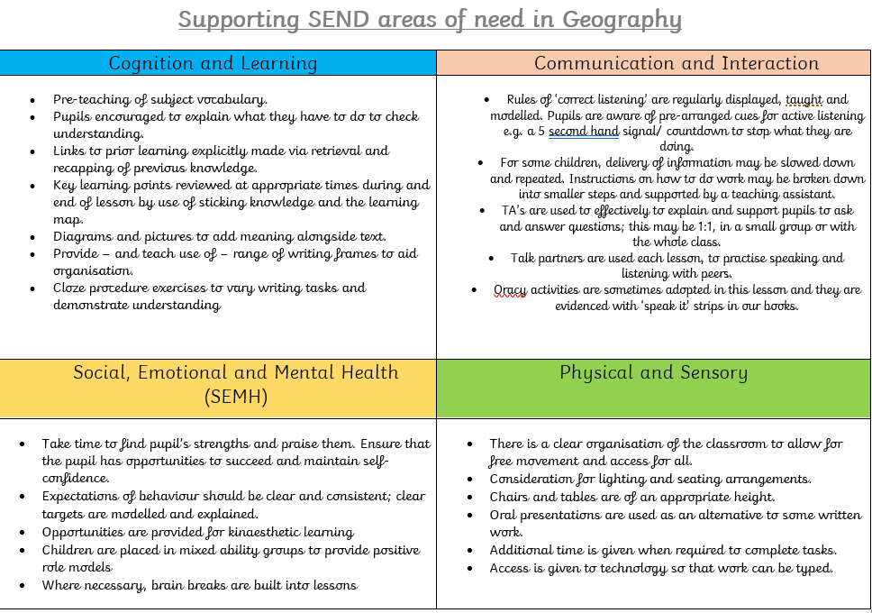

Impact
At the end of the unit, teachers deliver an assessment task to give children the opportunity to share their knowledge from that topic. The impact tasks involve an extended end of unit quiz to recall facts and knowledge. In the Spring and Summer terms, the children are also asked to write at length to demonstrate the knowledge they have gained. SENd children are to produce a detailed mind map. Teachers use the quiz, extended writing, detailed mind map to formally assess each individual child. They are assessed against National Curriculum objectives to be working towards the year group expectation (WTS), working at the expected standard for their age group (EXS) or working at greater depth (GDS) within Computing. Staff input the children’s initials on their year group assessment document (found on the shared drive). This is used to formulate an end of year judgement for the child’s summative assessment, recorded on the pupil’s end of year report.
Any photographic and video evidence (weather reports, for example) should be saved in the shared area as evidence for assessment. Pupils can also be assessed against their retrieval of the knowledge organiser.

Computing Lessons
We use a variety of teaching and learning styles in our Computing lessons. We believe in enquiry-based research activities to promote independent use of skills. We encourage children to ask and answer Geographical questions with personal relevance. Children are given opportunities to develop and apply skills in using a variety of data, such as maps, statistics, graphs, pictures, and aerial photographs. ICT is used within Computing lessons to enhance learning.
We involve children in Geographical activities with realistic contexts and purposes to help develop their sense of community responsibility and understanding of global citizenship. Children participate in role-play and discussions and present reports to the rest of the class and engage in a wide variety of problem-solving activities.
Computing has natural links to other subjects in the curriculum. Computing makes a significant contribution to the teaching of English in our school because it actively promotes the skills of reading for information, writing, speaking and listening.
Computing contributes to the teaching of mathematics in a variety of ways. We teach the children how to represent objects with maps. The children study space, scale and distance and they learn how to use four- and six-figure grid references. They also use graphs and charts to explore, analyse and illustrate a variety of data.
We make provision for the children to use ICT in Computing lessons when we feel that the use of ICT will enhance learning. Children use ICT in Computing to develop their skills in data handling and in presenting written work and reports. They research information using the Internet, Google Earth and a range of software packages. Children also learn how to use a range of control devices such as Beebots, Roamers and Logitech equipment within Geographical contexts. Provision is also made for children to use digital cameras and camcorders to create, record and use photographic images.

Equal Opportunities
The Governing Body and School Staff are committed to ensuring that all members of the School Community are treated fairly and with equality. We will comply with relevant legislation and implement School policy in relation to race, equality, disability equality and gender equality.
In Computing, the children are exposed to the diverse and multi-cultural world in which we live in. They are taught to respect differences in people, places and communities. We provide a quality education that is inclusive and equips our children to be lifelong learners. We encourage confident, caring and respectful citizens at all times.

Pupils’ Records of work
Pupils record their work in their Computing book. The work is expected to be of the same standard as that in English and Maths books. Fieldwork and observational skills can be recorded using photographs and videos and added to the Teacher’s shared drive. Each half term, children are expected to complete an extended piece of writing in their Computing book.
Resources
Resources are kept both in a central store and within each class teacher’s general resource areas for use when appropriate. Children in both key stages have access to a wide range of resources such as atlases, globes, maps and practical equipment to assist their learning and development of key Geographical skills.

Strategies for the teaching of Computing
We use a variety of teaching and learning styles in our Computing lessons. We believe in enquiry-based research activities to promote independent use of skills. We encourage children to ask and answer Geographical questions with personal relevance. Children are given opportunities to develop and apply skills in using a variety of data, such as maps, statistics, graphs, pictures, and aerial photographs. ICT is used within Computing lessons to enhance learning.
We involve children in Geographical activities with realistic contexts and purposes to help develop their sense of community responsibility and understanding of global citizenship. Children participate in role-play and discussions and present reports to the rest of the class and engage in a wide variety of problem-solving activities.
Best Practise in Computing
The subject leader has researched strategies for best practice from national associations for Computing, such as the GA, (Geographical Association) and the RGS (Royal Geographic Society). Examples of best practice in Computing is shared with teachers before they begin a Computing topic, these include high-quality examples of expected outcomes. The documents ‘What does best practice in Computing look like?’ And ‘What your books look like for Computing,’ can be found on the school’s centrally shared system, always available for teaching and support staff to access to reflect upon.

Classroom Support
Teaching Assistants and helpers are used in Computing to assist:
· In the classroom throughout the school by working with groups and individuals on task.
· In providing targeted and positive support to those pupils identified with difficulties.
· In providing other help, such as preparation of resources and display work.

Display
All classes have a ‘knowledge Organiser’ displayed on the wall. The children’s knowledge of places in Computing lessons is signposted on the map. Additional knowledge of places in other subjects, e.g musicians, historians, significant world events, are also identified on the map to widen the children’s knowledge of the world. The map is added to throughout the year.
Teachers display the key vocabulary for their Computing topic on their class working walls as part of their KW and ASPIRE display. At the start of a topic what the children already know is recorded. As children understand and become confident with the geographical vocabulary they are learning the vocabulary is moved from W for what they want to know to the ASPIRE section for what they have now learned.
Rewards
Children’s work will be rewards using praise, stickers, house points inline with the school behaviour policy. Staff may also recognise individual talents in Computing or specific work and celebrate this in our whole school Celebration assembly. The children will be rewarded with a certificate, outlining their achievement.

Appendix 1 – ‘What ASPIRE looks like in Computing’
- What do you aim to achieve in your curriculum?
At St. Stephen's School, our Computing curriculum is designed to equip pupils with the knowledge, skills, and confidence to thrive in a rapidly evolving digital world. We aim to inspire curiosity, creativity, and critical thinking through meaningful and engaging lessons that reflect real-world applications of technology. Our curriculum ensures that all pupils develop a solid understanding of computational thinking, programming, and digital literacy, preparing them to be not only competent users of technology but also responsible digital citizens.
We believe in fostering resilience, problem-solving, and collaboration as key skills in Computing, enabling pupils to take risks, experiment with ideas, and persevere through challenges. At the heart of our Computing curriculum is the commitment to inclusivity and accessibility, ensuring that every child, regardless of ability, is given the opportunity to succeed and develop their digital competence. Through a focus on e-safety, we also ensure that pupils understand the importance of staying safe online and the ethical use of technology in our interconnected world.
Our intent is to prepare pupils for future opportunities in a technology-driven society, empowering them to be confident, responsible, and innovative digital leaders in a diverse and ever-changing global community.

A – A whole school curriculum with high expectations and excellence delivered rigorously through well sequenced subjects, progression in generative knowledge, rich vocabulary, concepts and skills.

Our Computing curriculum is designed with high expectations and a commitment to excellence, delivered rigorously through well-sequenced lessons that ensure clear progression in generative knowledge, rich vocabulary, and essential skills. Each year builds upon prior learning, ensuring that pupils develop a deep understanding of key concepts such as algorithms, coding, data handling, and digital literacy. Our carefully structured curriculum promotes a logical progression of skills, where foundational knowledge is revisited and extended as pupils advance. We emphasize the use of rich, subject-specific vocabulary and ensure that pupils not only understand computing concepts but can articulate and apply them confidently. Through this approach, we provide a robust and comprehensive computing education that prepares pupils for the digital demands of the future.

S –Stimulating enquiring minds by providing rich and relevant experiences, purposeful and connected learning, and creative thinking.
We stimulate enquiring minds in Computing by providing rich and relevant experiences that encourage purposeful, connected learning and foster creative thinking. Our Computing curriculum is designed to engage pupils through real-world applications of technology, from coding interactive games to designing digital projects that link to other subjects such as mathematics, science, and art. We promote problem-solving and experimentation, allowing pupils to explore innovative solutions to challenges while developing critical computational skills. By connecting learning across disciplines and encouraging creativity in how technology is used, we nurture a sense of curiosity and inspire pupils to become confident, independent digital thinkers
P – Placing nurturing, lifelong learning behaviours – resilience, risk taking, independence, perseverance, and pride in success ​- at the heart of our curriculum.

At St. Stephen's, our Computing curriculum places nurturing lifelong learning behaviours—such as resilience, risk-taking, independence, perseverance, and pride in success—at its core. We encourage pupils to take risks by experimenting with coding, debugging, and problem-solving in a safe and supportive environment, helping them learn from mistakes and grow in confidence. Independence is fostered through opportunities for self-directed projects, where pupils take ownership of their learning and explore their own ideas. We celebrate perseverance by recognising effort and progress, ensuring pupils feel a sense of achievement as they overcome challenges. Through this approach, we instill pride in their successes, cultivating the resilience and mindset needed for lifelong learning in an ever-evolving digital world

I – Inclusivity and flexibility which allows us to cater for individual needs, abilities and interests
Our Computing curriculum is built on inclusivity and flexibility, ensuring that we cater to the diverse needs, abilities, and interests of every pupil. We provide differentiated learning opportunities that allow pupils to access the content at their own level, whether they require additional support or are ready for greater challenges. Lessons are designed to be adaptable, incorporating a range of teaching methods, tools, and technologies to engage all learners. We also encourage pupils to pursue their individual interests within Computing, offering them the flexibility to explore topics that spark their curiosity, from game design to digital art. By creating an inclusive environment, we ensure that every child feels valued and is given the opportunity to succeed in developing their digital skills.
R- Revisiting key knowledge, skills and vocab, so pupils know more and remember more​.
At St. Stephen's, we prioritise the revisiting of key knowledge, skills, and vocabulary in our Computing curriculum to enhance pupils’ retention and understanding. Through a well-structured sequence of lessons, we regularly integrate retrieval practices at the start of each lesson. This cyclical approach allows students to build upon their foundational knowledge systematically, ensuring that essential vocabulary and skills become firmly embedded in their learning. By revisiting and expanding on these core elements, we enable pupils to not only know more but also to recall and apply their knowledge confidently, preparing them for more advanced topics and real-world applications in Computing.
E -Encompassing the Whole Child – developing their faith, values, spirituality, health and well-being, and understanding of the world we live in, their future role in our culturally diverse community and country where equality and tolerance is promoted
We are committed to encompassing the whole child in our Computing curriculum by integrating the development of faith, values, spirituality, health, and well-being into our teaching practices. We recognize the importance of educating pupils about the ethical use of technology and digital citizenship, fostering a sense of responsibility and respect in an increasingly interconnected world. Our curriculum promotes discussions around equality and tolerance, encouraging students to explore diverse perspectives and cultures within the digital landscape. By incorporating themes related to well-being and mindfulness and online safety in technology use, which is embedded throughout the Computing Curriculum, we help pupils understand the impact of their digital choices on themselves and others. Through this holistic approach, we aim to equip students with the skills and values necessary to thrive as compassionate and informed members of our culturally diverse community.

What is the reason for your curriculum design?
In Computing, the curriculum has been designed to focus around three geographical strands:
- Geographical skills and fieldwork
- Global issues
- Human and physical features – comparisons with another location.

The LTP for Computing has been designed this way to allow for progression in map skills and knowledge of places beyond our locality. The children will benefit from finding out about their local environment in relation to our country, continent and the world around them. In our Computing teaching, we will provide the children and parents with opportunities to experience and gain an interest in their immediate world and how this impacts on the wider world.

- How did you achieve class teachers/ TA sharing this understanding before they teach your subject?
Computing has been at the forefront of the new curriculum, along with History. We valued support from the Geographical Association to provide us with key learning points curriculum journey. Staff meetings were assigned to the development of this subject, so that all stakeholders had the opportunity to understand the development and reasoning behind the curriculum design. This has developed into documents, accessible to all to demonstrate what Computing should look like in books. We aim to use this as a ‘go to’ document to improve consistency and expectations in books.
As the subject leader, part of my role is to ensure that staff have a topic overview and knowledge organiser as their starting point. From this, they can create their own plans, focusing on the specific lesson objective stated on the MTP. IN the development of the new curriculum, all subjects are now expected to start their new topic with a double page spread of the topic cover sheet and knowledge organiser. As this is repeating across subjects, the expectation is now embedded in our practice.
Alongside staff meetings; valuable, informal conversations regularly take place to check on understanding and clarify any questions that staff may have. Rigorous monitoring ensures that staff have the correct expectation and understanding of the subject.

- Explain what knowledge, progression and sequencing means in your subject?
Knowledge is (an example):
In Computing, we aspire for the children to know about their location and where that is in relation to their country, capital city and the world beyond where they live. Teaching should equip pupils with knowledge about diverse places, people, resources and natural and human environments, together with a deep understanding of the Earth’s key physical and human processes. As pupils progress, their growing knowledge about the world should help them to deepen their understanding of the interaction between physical and human processes, and of the formation and use of landscapes and environments. Geographical knowledge, understanding and skills provide the frameworks and approaches that explain how the Earth’s features at different scales are shaped, interconnected and change over time.

Progression can be shown through each geographical strand:
- Map skills: In KS1, children use the 4 points of the compass, reading and drawing maps of the school environment and the local area. This progresses to using 8 points of a compass in Y3 and four figure grid references in Y4. In Year 5 and 6, children use 6 figure grid references when map reading.
- Locational knowledge: In KS1, children focus on their locality and the countries of the UK. They learn about the continents and oceans around the world. IN KS2, the children’s locational knowledge develops to other countries and their capital cities in Europe and in contrasting continents.
- Place knowledge: In KS1, children focus on vastly contrasting locations than their own environment to make the contrast in human and physical Computing more explicit. IN LKS2, their place knowledge develops to the position and significance of the Equator, Tropics and Hemispheres. Children progress in this strand to knowledge of latitude and longitude and time zones in UKS2.
- Human and Physical Computing: In KS1, children identify seasonal and weather patterns where they live. They use geographical vocabulary to refer to physical and human features. In KS2, the children focus upon biomes, natural disasters and settlements.

The Computing curriculum is sequenced to explore three main strands – 1 per term:
- Geographical skills and fieldwork
- Global issues
- Human and physical Computing
The curriculum has been sequenced in this way to provide opportunities to retrieve their knowledge learned from previous years and to build upon this. For example, when studying human and physical Computing, the children start off in KS1 with vastly contrasting localities to their own environment. They build upon this knowledge of the world to learn about the Computing of other places in the other continents around the world. The curriculum in KS1 commences with the school environment, building upon the sequence of learning from EYFS: Understanding the World. In EYFS, children observe changes and differences in their environment and this is built upon in KS1 and 2 as children understand why these changes happen.
The sequence has been carefully mapped out to ensure that concepts build upon one another. Please see supporting document to see further explanation of the sequencing of Computing.

- How do you promote Reading, Writing and Maths in your subject?

At the start of each lesson, children ‘read’ their Knowledge organiser. This is a document where they are exposed to and learn new subject-specific vocabulary. The children read the definitions to deepen their understanding. During lessons, staff plan high-quality tasks that give opportunities for reading across the curriculum. This may be in the form of reading maps and atlases for geographical enquiry, but can also be reading non-fiction books about contrasting localities, or reading diagrams and explanations of the water cycle, for example.
Lessons commence with a retrieval quiz, in which children read questions and demonstrate their learning from the previous lesson. This provides another opportunity for reading.

Writing is demonstrated in nearly all Computing lessons, from annotating and labelling maps, to writing a detailed explanation of how volcanoes are formed.
At the end of the Spring and Summer units, the children are given the opportunity to demonstrate their knowledge in an extended writing task. Although this is a Computing assignment, staff ensure that high quality English written work is demonstrated relating to age related expectations.

Computing is a numerate subject and uses mathematical concepts in some way in most lessons; for example, numbers, scale, graphs, data, temperatures, percentages, ratios, co-ordinates. Knowledge about places, issues and maps are presented to the children using various data, e.g. pictograms, bar diagrams, etc. The children need to read and interpret this data, using their Maths knowledge.

Appendix 2 – How the Computing ASPIRE curriculum meets the needs of the National Curriculum.’
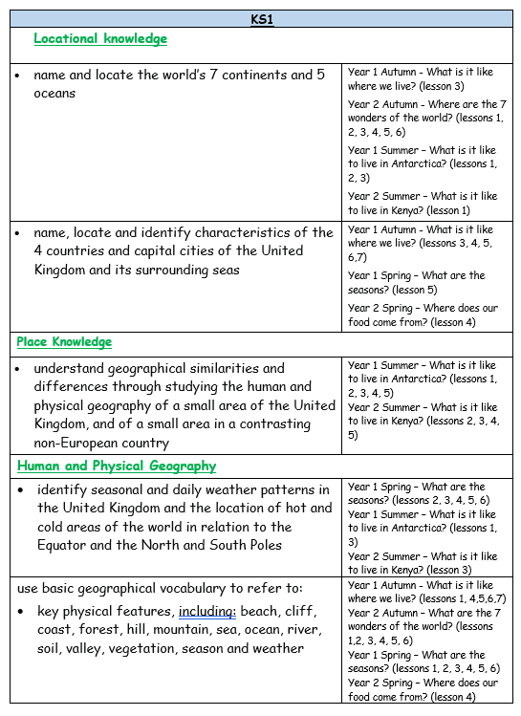
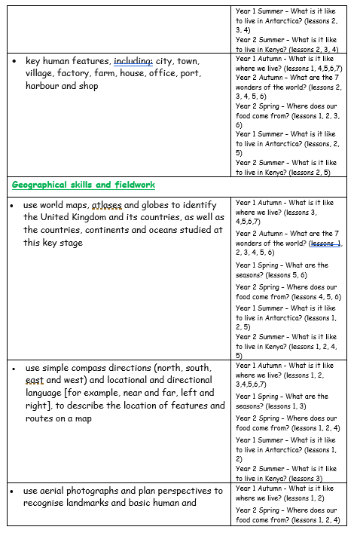

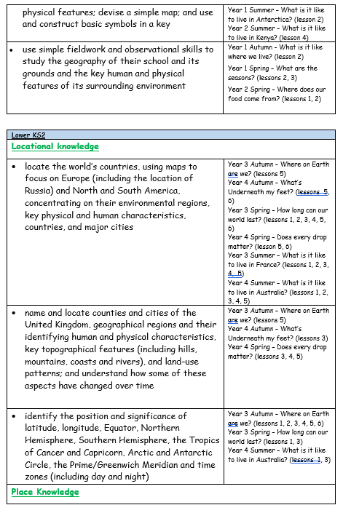
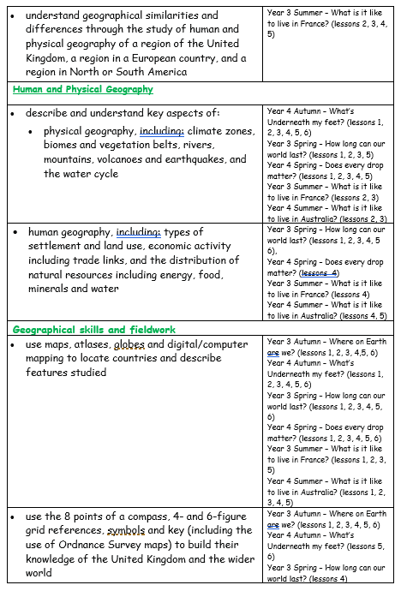
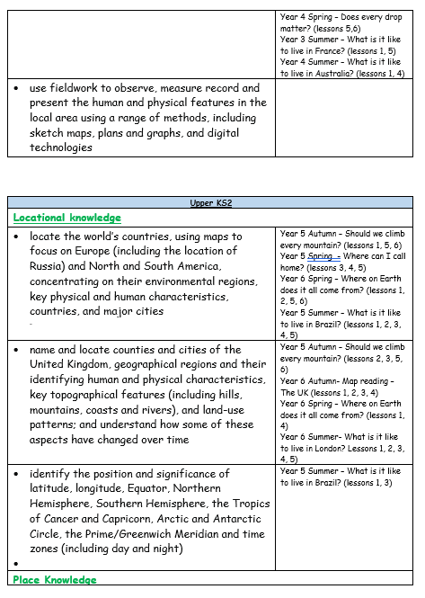
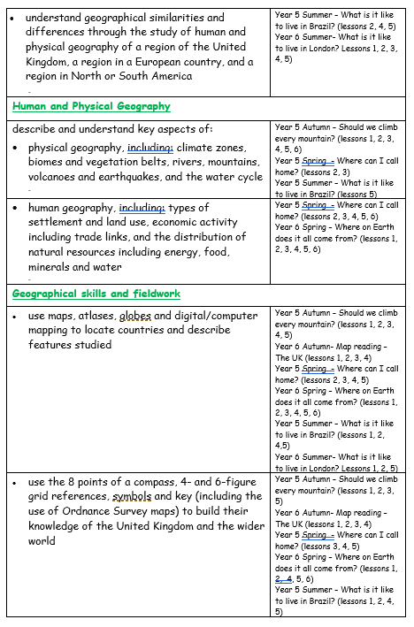
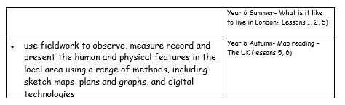
Appendix 3 – ‘Best practise for teaching and learning’
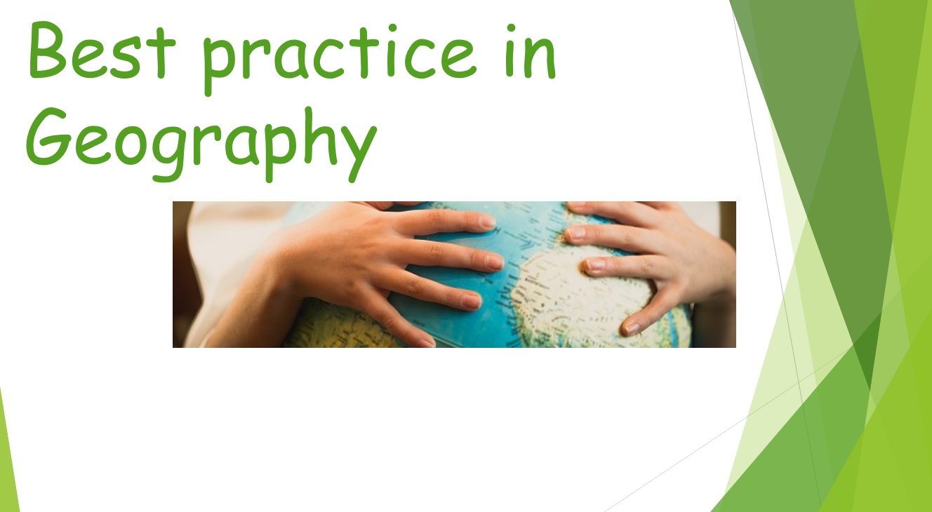

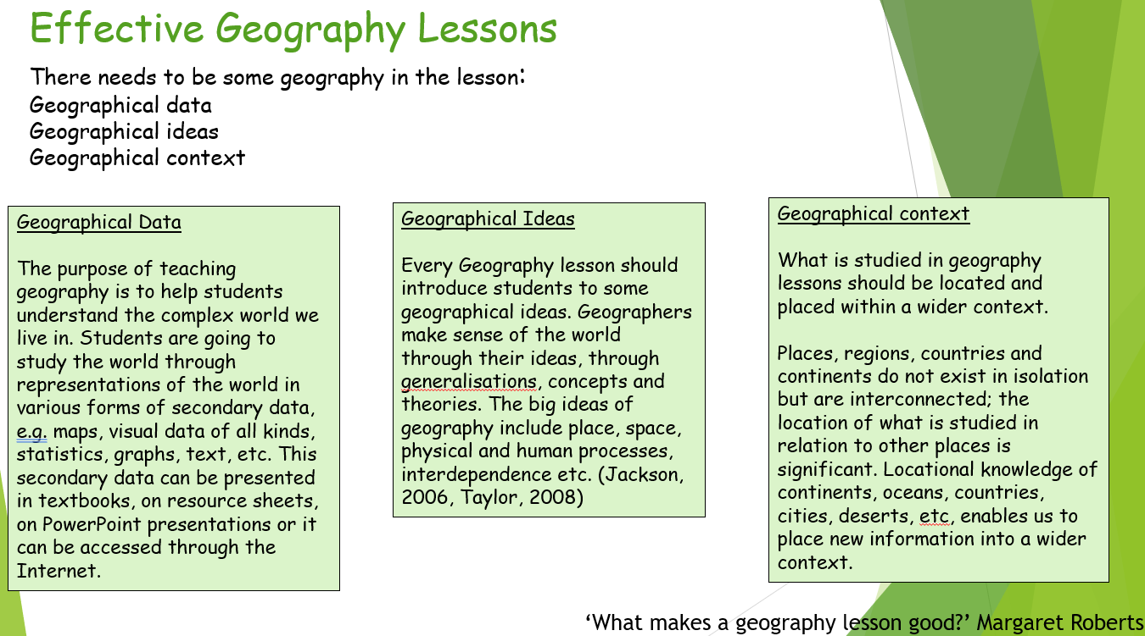

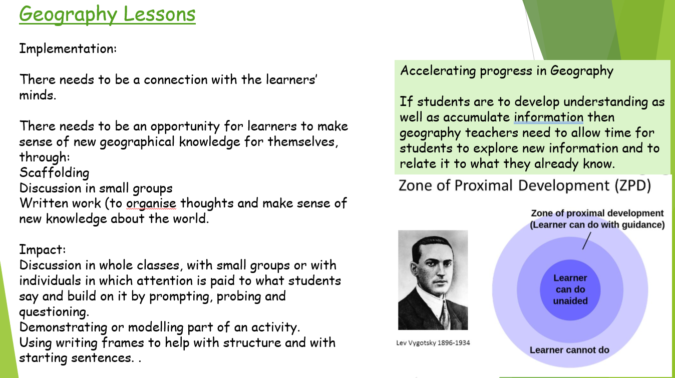

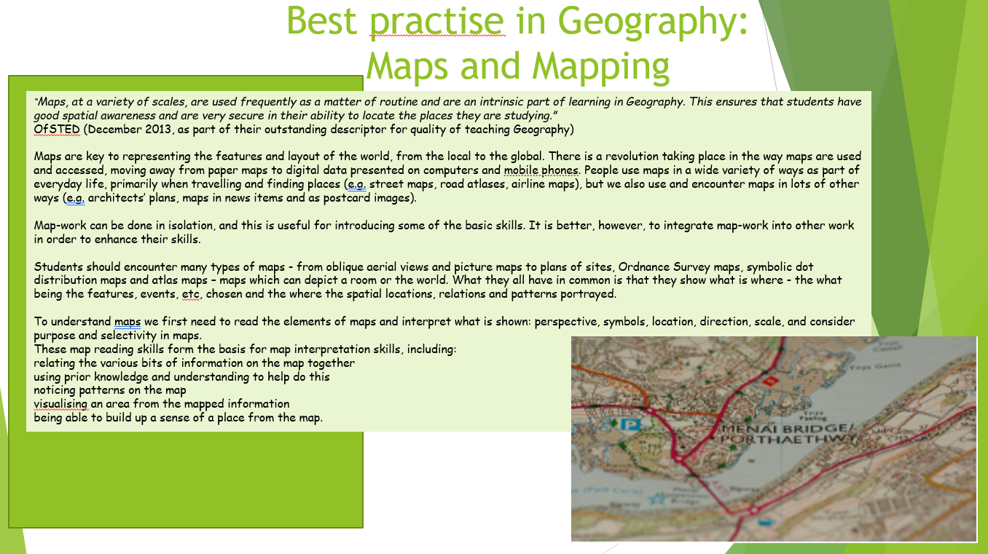

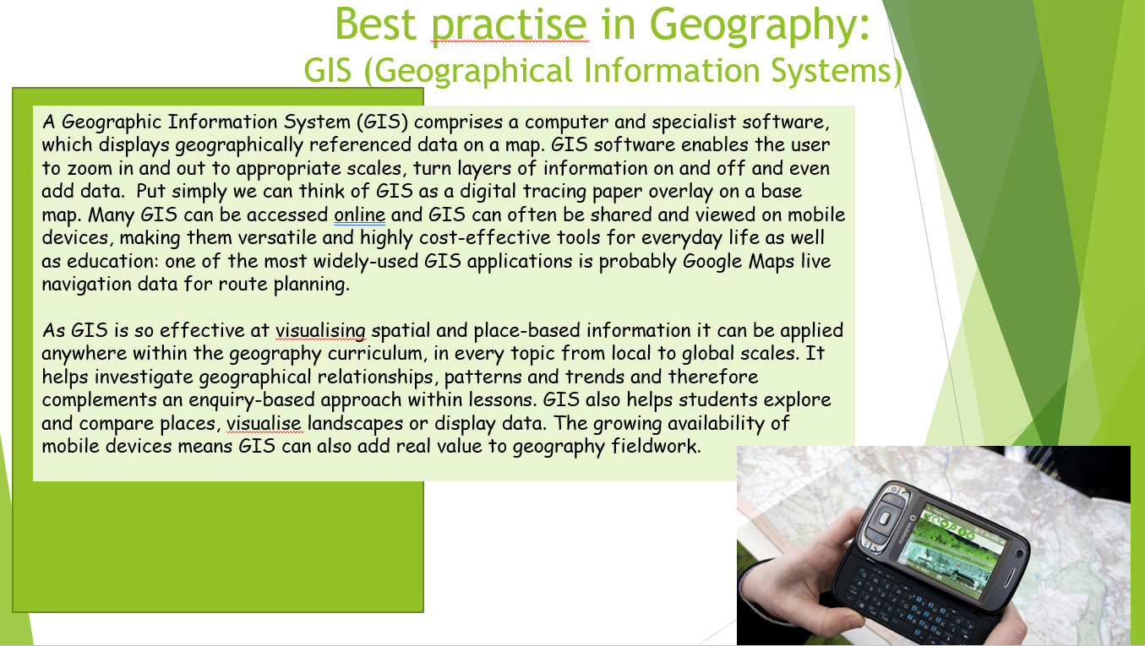

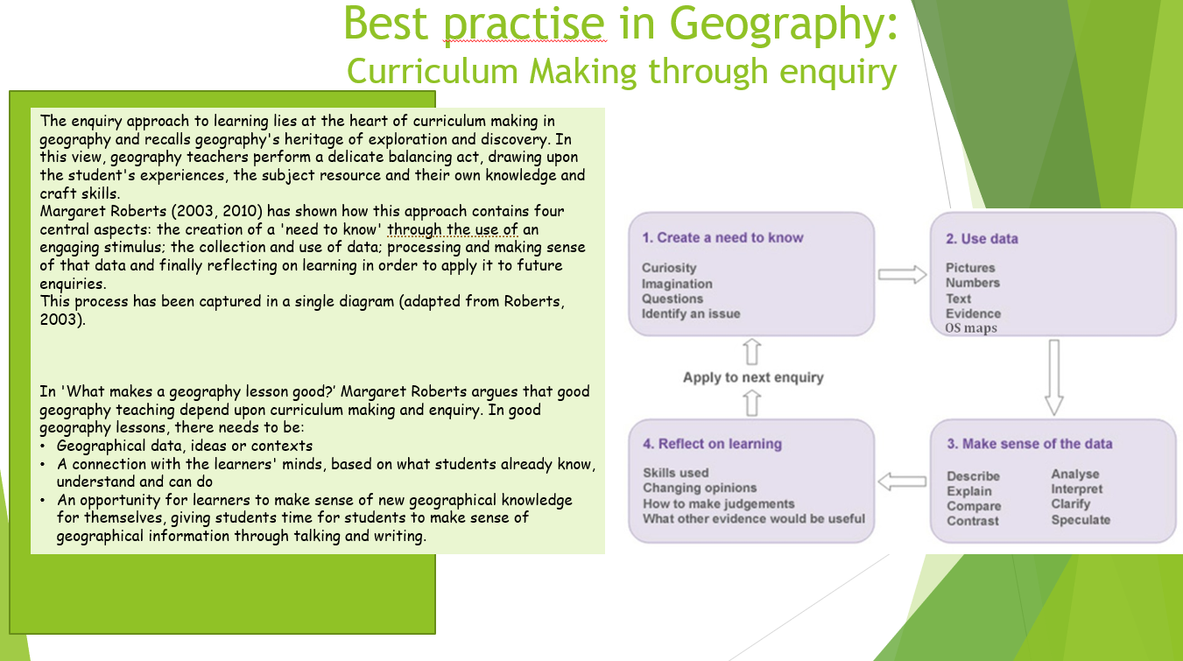

Appendix 4 – ‘EYFS in Computing’
Computing within the EYFS takes place withing the specific area of Understanding the World. The aim for our EFYS children is to achieve the Early learning Goals, as listed below:
- Describe their immediate environment using knowledge from observation, discussion, stories, non-fiction texts and maps.
- Know some similarities and differences between different religious and cultural communities in this country, drawing on their experiences and what has been read in class.
- Explain some similarities and differences between life in this country and life in other countries, drawing on knowledge from stories, non-fiction texts and – when appropriate – maps.
- Explore the natural world around them, making observations and drawing pictures of animals and plants
- Know some similarities and differences between the natural world around them and contrasting environments, drawing on their experiences and what has been read in class
- Understand some important processes and changes in the natural world around them, including the seasons and changing states of matter.

Within this area of learning children within the EYFS at St Stephen’s CE are immersed in a curriculum which encompasses geographical learning, for example scrutinizing seasons, delving into space exploration, discussing contrasting localities as well as examining the local area. These geographical skills ensure the children transition seamlessly to Key Stage One, with the necessary skills to flourish within Computing.

Appendix 5 – ‘What my books will look like in Computing’
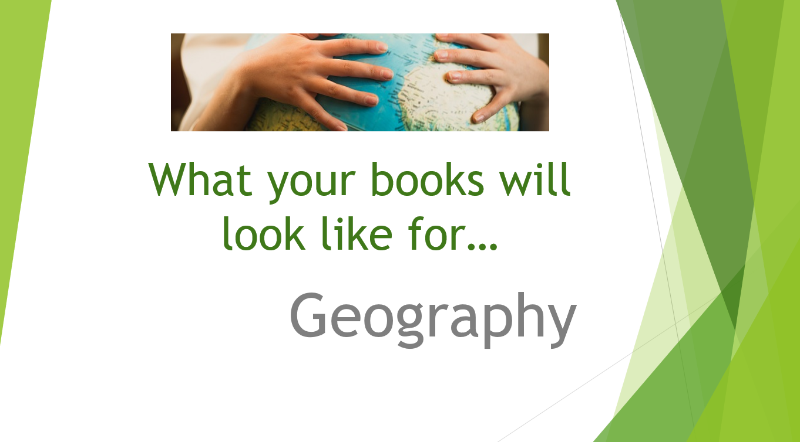

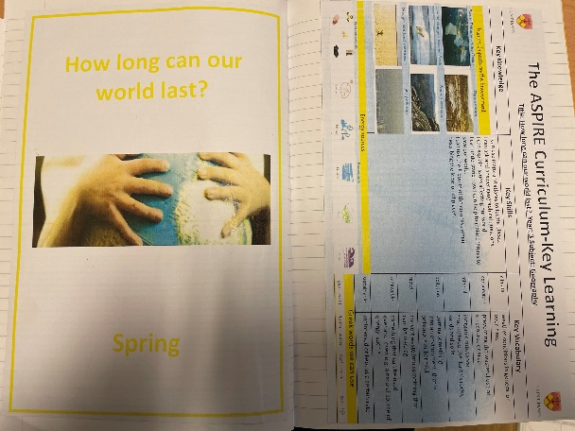
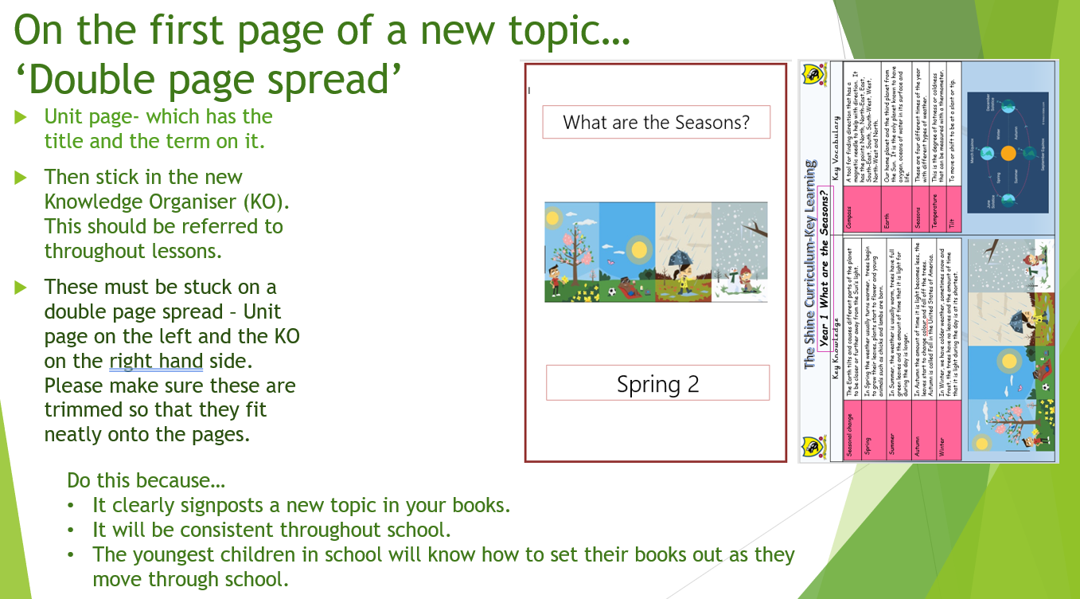

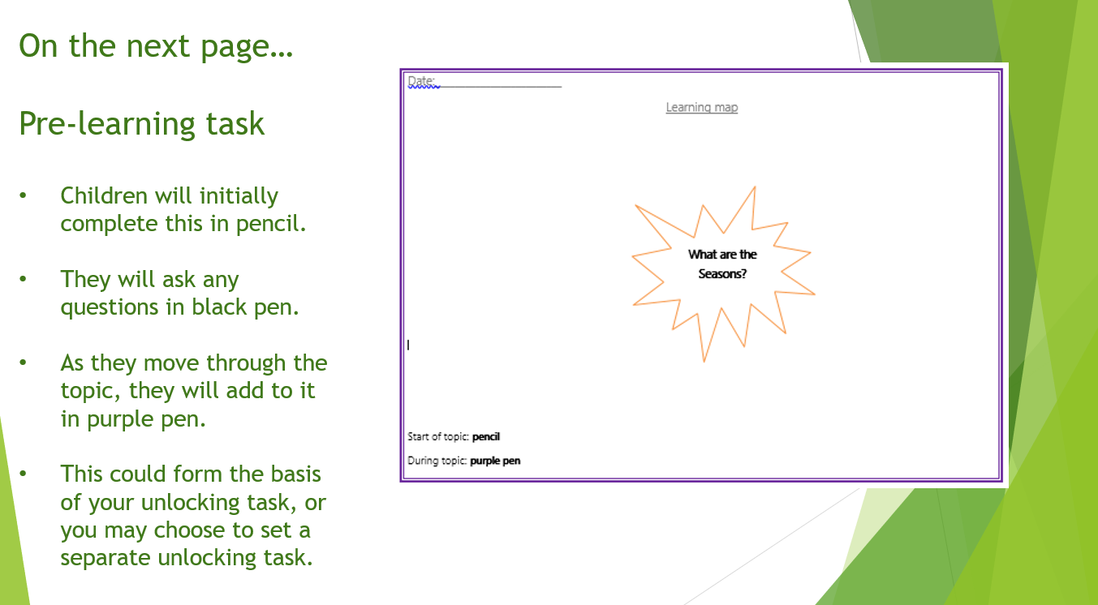

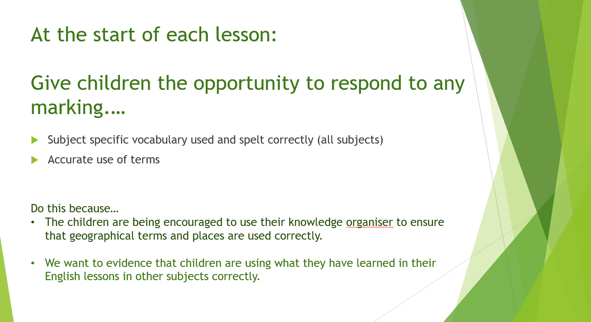

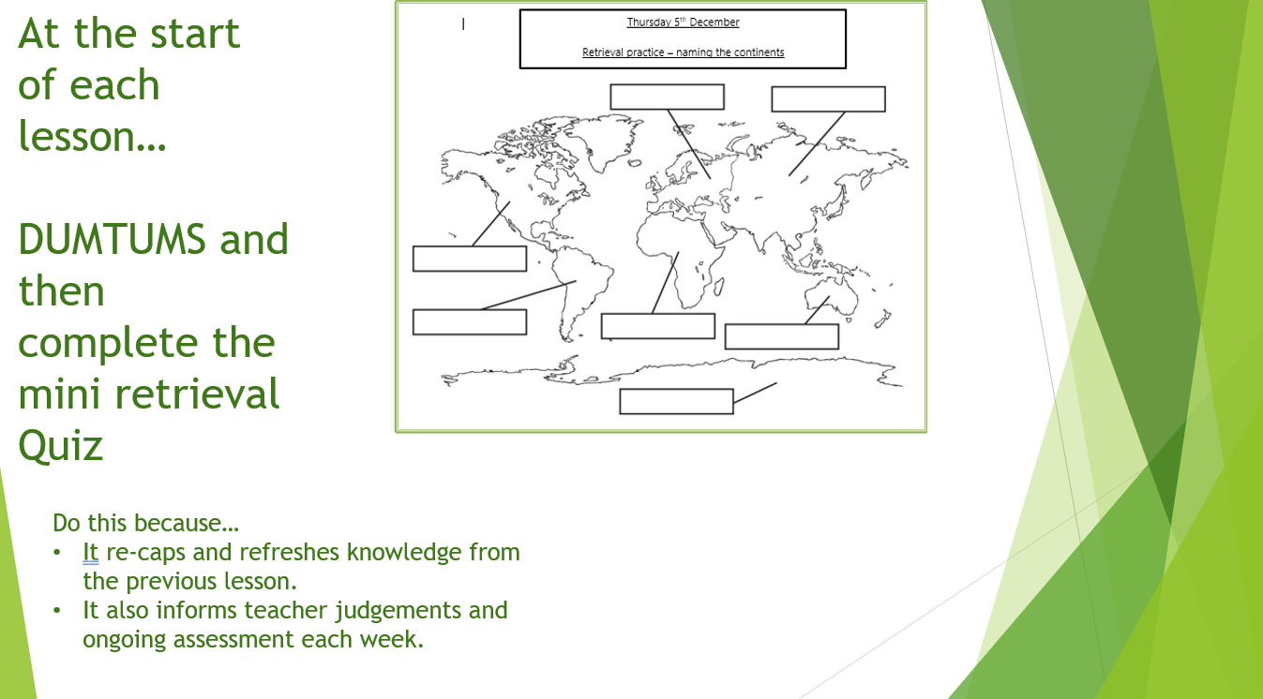

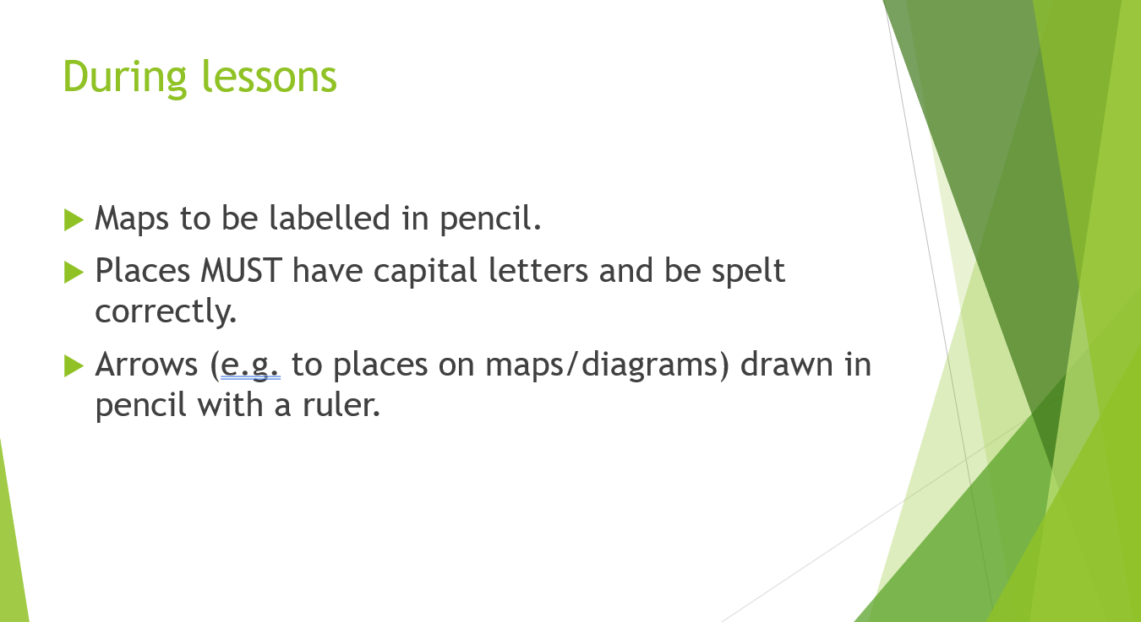

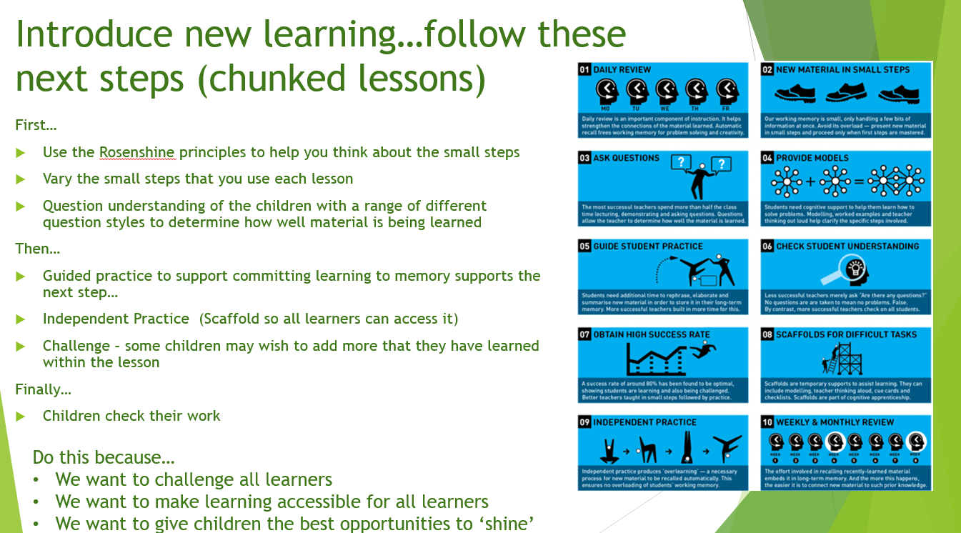

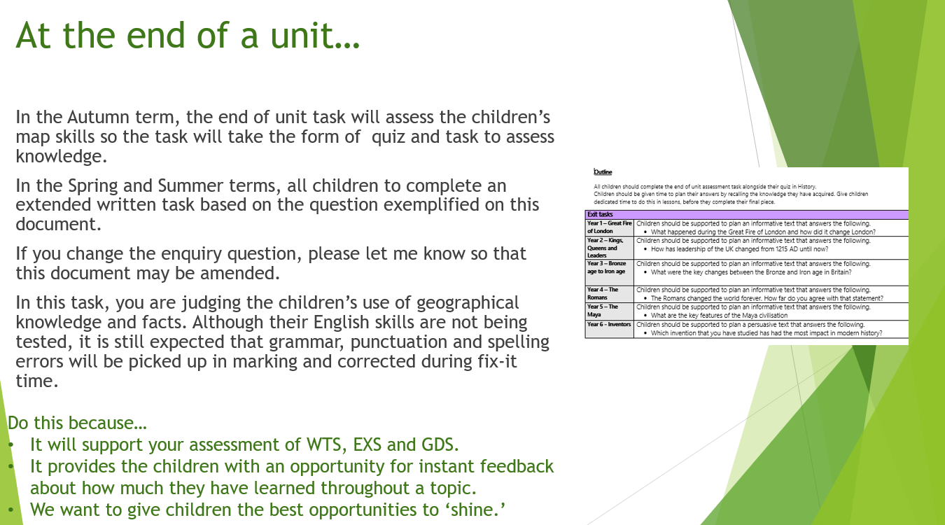

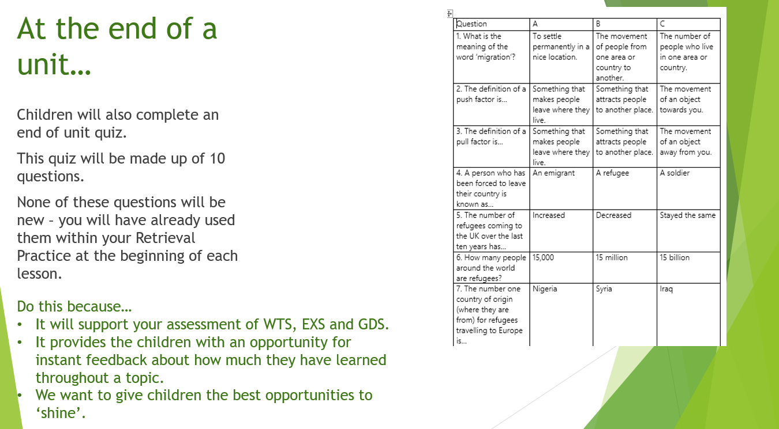

Appendix 6 – ASPIRE in Computing

A 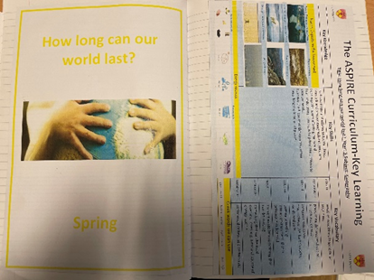
S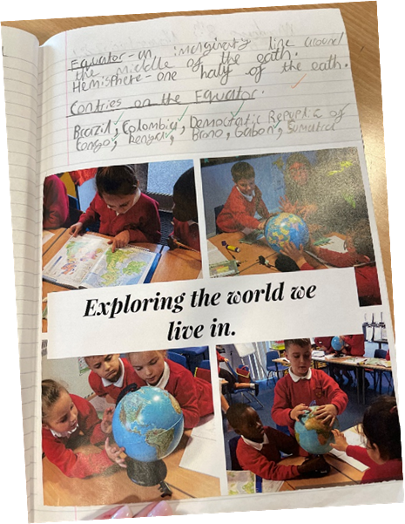
P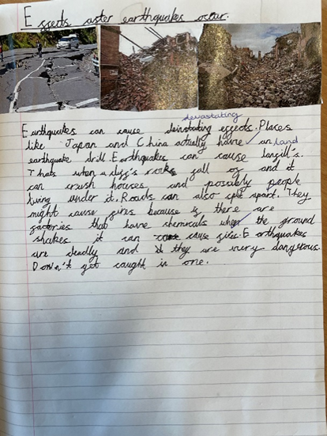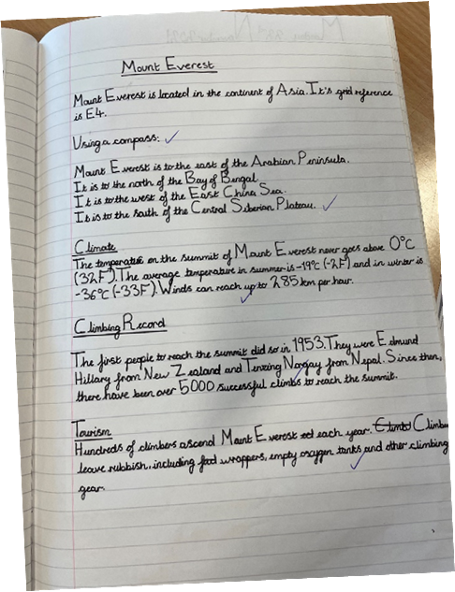
I 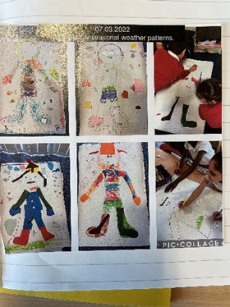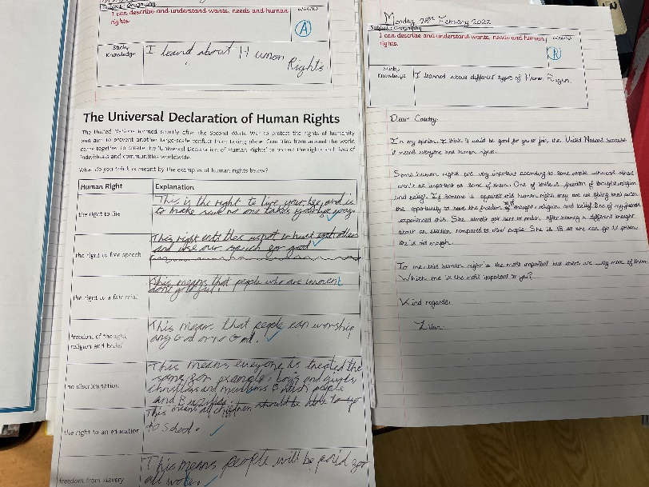
R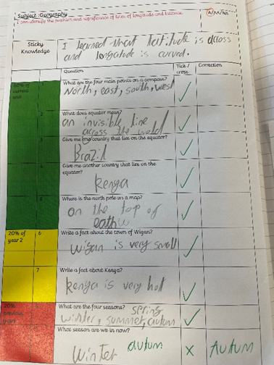
E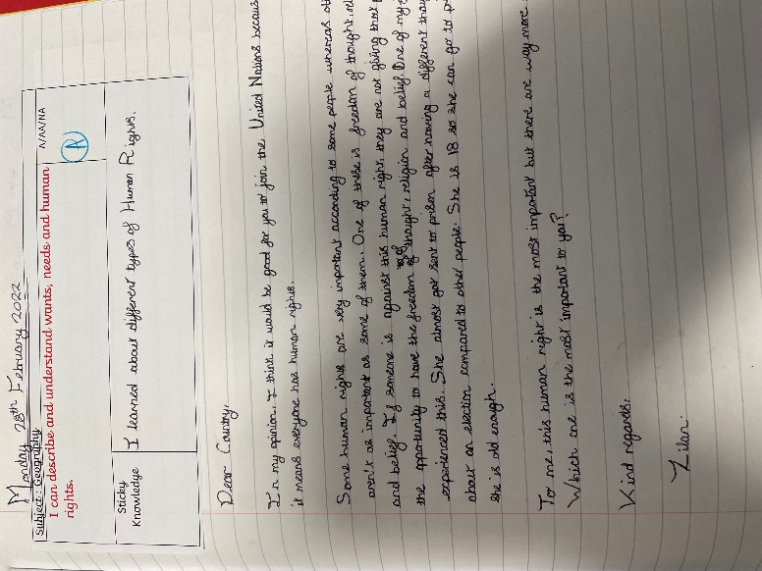

Appendix 7 – Long term plan
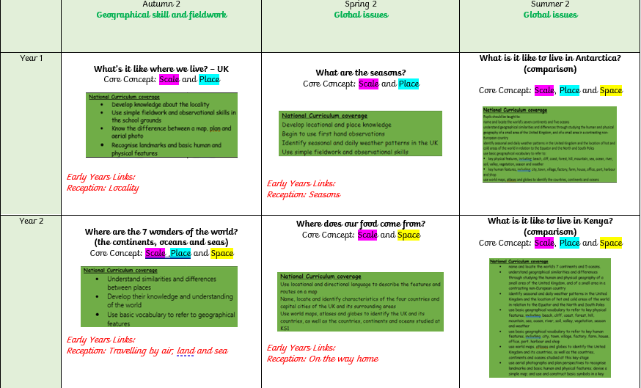
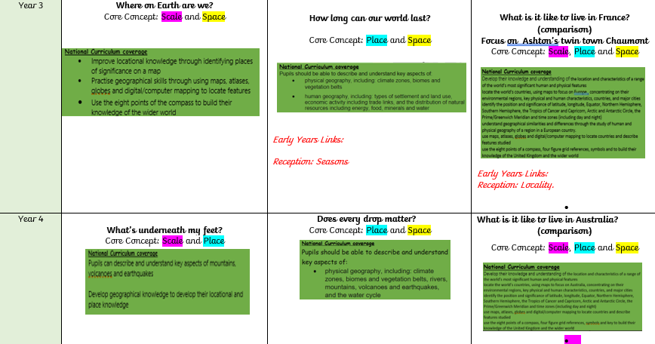
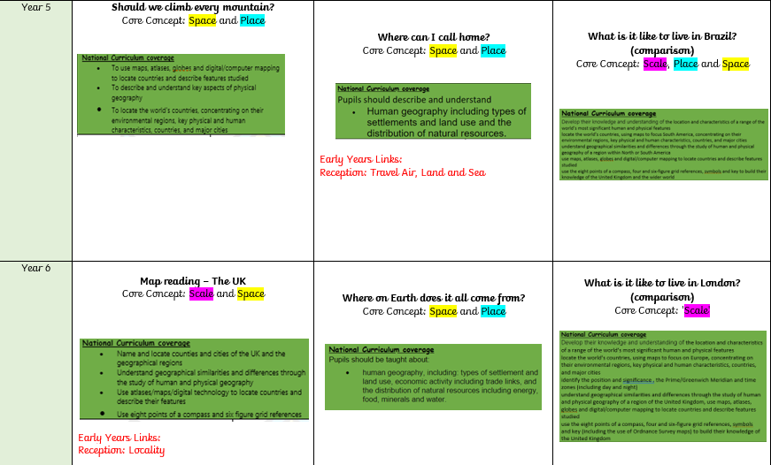

Curriculum Flow Chart

Step 1
Look at the MTP
- Ensure that you know the key skills and substantive concepts which need to be covered for the topic and that they are planned in (find these on the MTP).
- Take note of what has been taught before and what will follow (find these on the MTP).
- Take note of any cross curricular links

Step 2
- Lesson 1 – Ensure that the title page and KO are on a double spread in pupils’ books and that the learning map is stuck on the next page.
- Children should then fill in what they already know before the start of the topic in pencil.

Step 3
- Each lesson should follow a five point lesson model which includes:
- Retrieval and Challenge
- Review key knowledge
- Hook and Introduction (Vocabulary, Knowledge and skills)
- Teacher guided section
- Independent section

Step 4
- Ensure that throughout the topic pupils record on their learning maps (in green pen) what they have learned in each lesson and 1 key piece of information should be recorded as part of their sticky knowledge.
- Planning should also indicate clear differentiation and support given for specific PP and SEN children and the role of the TA.

Step 5
- At the end of each unit of work each child should complete an assessment task appropriate to their level. This could include a mind map, piece of extended writing, a quiz or project as a way of showcasing the skills and knowledge they have acquired during that unit of work.

