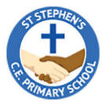


Year 5 Curriculum Overview
Autumn 2 - 2025

SCIENCE
This half term in Science our unit is Forces. In this unit, we will be investigating how forces act on objects, exploring the effect of gravity, friction, water and air resistance. Also exploring and designing a range of mechanisms.
P.E. This half term, the children will be having a PE lesson on a Monday and also on a Friday. Please ensure children come to school in the correct PE for both days.

ENGLISH - This half term in English we will be reading Ahmed and the Feather Girl and focusing our writing on producing a traditional tale. We will then move on to produce a recount.

MATHS - In Maths, we will continue multiplication and division by multiplying and dividing by powers of 10. We will then move on to fractions where we will be recognising equivalent fractions, converting from mixed numbers to improper fractions, converting to improper fractions to mixed numbers and comparing and ordering fractions.

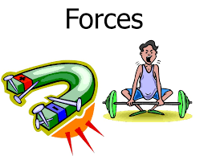
FRENCH
In French, we will be learning all about ourselves and how we can describe our body parts and also our fashion sense in French.


R.E.
In RE, we will be exploring the question ‘Why Hindus want to be good in their everyday life?’ and delving deeper into the Hinduism religion.

GEOGRAPHY
This half term in Geography we will be looking at where we call home. Using our map and atlas skills and identifying factors that affect human movement.

MUSIC
In Music, we will be learning about a range of jazz music and how to improvise with the same two tunes: Three Note Bosa and Five Note Swing.
DESIGN &TECHNOLOGY
In DT this term, we will be exploring electrical systems and motors to be able to produce our own doodlers!
PSHE
In PSHE, we will be celebrating our differences, looking into different cultures, types of bullying and if money matters in our world.

MUSIC
We will be learning about rhythm and music notation.

